CHAPTER 1
INTRODUCTION

Agriculture is one of the most important sectors in the country and plays a major role in the daily life and economy of people. Farmers work hard to grow crops and supply food, but they still face many problems such as low profits, lack of direct market access, dependency on middlemen, and limited use of technology. In many cases, farmers do not receive the correct market price for their crops because brokers and intermediaries take a large share of the profit. Farmers also face difficulties in crop diseases, market trends.
Farmogram is a smart web-based agricultural platform developed to help farmers manage farming activities more efficiently using digital technology. The system creates a direct connection between farmers and buyers through a single online platform. Farmers can list and manage their crops, monitor farming activities, and communicate directly with buyers without depending on middlemen. Buyers can search for available crops, contact farmers, negotiate prices, and place orders easily through the system. This helps improve transparency and allows farmers to earn better profits for their products.
The platform includes several useful features that support both farmers and buyers. Buyers can view crop listings, check product details, and track orders after purchase. The communication system allows direct interaction between farmers and buyers, making the buying and selling process faster and easier.
Farmogram also provides smart features such as weather updates, crop market price information, and AI-based assistance. The system also supports multiple regional languages so that rural farmers can use the platform comfortably without language difficulties.
Another important feature of the platform is the crop pre-booking system. Buyers can reserve crops before harvest by paying an advance amount, which helps farmers get financial support during the crop growing period. This reduces financial pressure on farmers and helps them manage expenses such as seeds, fertilizers, and irrigation. The system also includes crop insurance claim support where farmers can report crop damage caused by natural disasters or diseases and request assistance.
Overall, Farmogram aims to modernize the agricultural system by using technology to improve communication, transparency, productivity, and profitability in farming. The project helps farmers manage their work more effectively, provides better market opportunities, and creates a reliable digital platform for agricultural trading and support.
1.1 PROBLEM STATEMENT

Agriculture is one of the most important sectors, but many farmers still face several difficulties in managing and selling their crops. Most farmers depend on middlemen or brokers to sell their agricultural products. Because of this, farmers often receive very low profits while buyers pay higher prices. The lack of direct communication between farmers and buyers creates problems in pricing, trust, and transparency.
Farmers also face financial problems during the crop growing period. They need money for seeds, fertilizers, irrigation, and other farming activities, but they receive income only after harvesting and selling the crops. This forces many farmers to take loans, which increases financial pressure.
Another major problem is the lack of easy access to important agricultural information. Many farmers do not get proper updates about weather conditions, crop diseases, market prices, or farming advice at the right time. In rural areas, farmers may also find it difficult to use digital platforms because many systems are available only in English and are not designed for simple usage.
Managing farming activities manually is also difficult. Farmers often depend on memory to track watering, fertilizing, and harvesting schedules, which may affect crop productivity. In addition, crop damage caused by pests, diseases, or bad weather creates further losses, and the process of claiming insurance support is often slow and complicated.
Therefore, there is a need for a smart and user-friendly digital platform that can connect farmers and buyers directly, provide useful agricultural information, simplify farm management, and improve transparency in the agricultural system. Farmogram is developed to solve these problems by using modern web technologies and smart farming features.

1.2 OBJECTIVES

- Direct Farmer–Buyer Connection: To create a platform where farmers can directly sell their crops to buyers without depending on middlemen. This helps improve transparency and allows farmers to receive better profits.

- Financial Support for Farmers: To provide financial assistance during the crop growing stage through an advance crop booking system. This helps farmers manage farming expenses more effectively.

- Smart Crop Management: To help farmers manage crop details, cultivation activities, and important farming schedules in an organized manner. This improves productivity and reduces manual effort.

- Real-Time Communication: To enable direct interaction between farmers and buyers through enquiry and messaging features. This makes negotiation and order processing easier and faster.

- AI-Based Farming Assistance: To provide smart farming guidance such as crop disease detection and treatment suggestions using AI technology. This helps farmers make better farming decisions.

- Weather and Market Updates: To provide farmers with useful information such as weather forecasts and crop market prices. This helps in planning farming activities and improving sales decisions.

- Multi-Language Accessibility: To make the platform easy to use for rural farmers by supporting regional languages. This improves accessibility and user experience.

- Simplified Insurance Claims: To allow farmers to digitally submit crop damage reports and insurance claims. This reduces paperwork and simplifies the claim process.

- Order and Payment Management: To provide proper order tracking and payment management features for secure and transparent transactions between farmers and buyers.

1.3 PROPOSED SYSTEM

The proposed system, Farmogram, is a smart web-based agricultural platform developed to improve the traditional farming and crop selling process. In the existing system, farmers mainly depend on middlemen to sell their crops, which reduces their profit and creates a lack of transparency in the agricultural market. Farmogram provides a digital platform where farmers and buyers can connect directly, helping farmers receive better prices and buyers purchase crops more easily.
The system provides separate dashboards for farmers, buyers, and administrators. Farmers can add crop details, monitor crop growth, manage farming activities, and update crop prices. Buyers can browse available crops, send enquiries, negotiate prices, and place orders directly through the platform. The administrator manages users, monitors activities, verifies crop details, and handles insurance claims to ensure smooth system operation.
Farmogram also includes several useful features such as crop management, order tracking, payment management, and real-time communication between farmers and buyers. The farmers can manage farming activities like watering, fertilizing, and harvesting through task reminders.
In addition, the platform includes AI-based support. The system also provides weather updates, crop market prices, and crop insurance claim support. Buyers can pre-book crops by paying an advance amount, which helps farmers get financial support during the cultivation period.
Key Features :
- Direct interaction between farmers and buyers without middlemen
- Crop management system for tracking crop details and farming activities
- Marketplace for buying and selling agricultural products
- Enquiry and messaging system for communication and negotiation
- Advance crop booking facility for financial support
- AI-based crop disease detection and farming assistance
- Weather updates and crop market price information
- Crop insurance claim support
- Multi-language support for rural farmers
1.4 MAJOR MODULES

1. Authentication and Authorization Module
This module handles the security and access control of the platform, ensuring users are directed to their respective dashboards based on their roles.
- User Registration: Allows Farmers, Buyers, and Admins to create accounts securely.
- Secure Login: Authenticates users using hashed credentials.
- Role-Based Access Control (RBAC): Manages permissions to ensure buyers cannot access farmer tools, and only admins can access the system overview.
- Account Recovery: Secure password reset mechanisms for users.

2. Farmer Management Module
This is the core module empowering agricultural producers to manage their operations and sales.
- Farmer Dashboard: A centralized hub displaying sales analytics, recent orders, and quick actions.
- Inventory & Produce Management: Allows farmers to add, update, and manage their crops, including pricing and stock levels.
- Autopilot Crop Calendar (Task Automation): Generates and tracks a full season's worth of actionable farming tasks based on specific crop lifecycles.
- Order Fulfillment: Interface to view buyer orders, update delivery statuses, and manage location-based logistics.

3. Buyer E-Commerce Module
This module provides a modern, seamless shopping experience for consumers looking to purchase directly from farmers.
- Marketplace Catalog: Displays available produce with filtering and search capabilities.
- Cart System: A dynamic, session-based cart featuring a modern Bento-Glass UI.
- Checkout & Promo Engine: Secure checkout process with the ability to apply promotional codes and discounts.

4. Administrator Module
This module provides system oversight and verification tools for platform operators.
- User Management: Admins can view, verify, or suspend farmer and buyer accounts.
- AI-Driven Crop Loss Verification: A specialized tool utilizing weather data and AI to verify and process farmer claims regarding crop failure or loss.
- Platform Analytics: System-wide metrics tracking sales volume, active users, and platform health.

5. AI and Intelligence Module
This module integrates third-party APIs to provide smart, proactive assistance to users.
- Gemini AI Voice Assistant: A voice-to-text enabled smart assistant that helps farmers with pest control, crop planning, and general queries.
- Weather Intelligence: Fetches real-time weather data to alert farmers about adverse conditions affecting their crops

6. Enquiry and Communication Module
This module enables direct communication between farmers and buyers for crop-related discussions and negotiations.
- Enquiry System: Buyers can send enquiries to farmers regarding crop availability, pricing, and quantity.
- Real-Time Messaging: Provides direct communication between farmers and buyers through the messaging system.
- Price Negotiation: Allows buyers and farmers to negotiate prices and finalize deals easily.
- Custom Offers: Supports custom bidding and offer management for crop purchases.
1.5 APPLICATIONS

1. Direct Farmer-to-Buyer Marketplace
Farmogram helps farmers sell their crops directly to buyers without depending on middlemen. This improves transparency and allows farmers to receive better profits for their products.

2. Crop Management and Farm Monitoring
Farmers can use the platform to manage crop details, monitor crop growth, and track farming activities such as watering, fertilizing, and harvesting schedules.

3. Pre-Booking of Crops
Buyers can reserve crops before harvest by paying an advance amount. This provides financial support to farmers during the crop cultivation period.

4. Real-Time Communication and Negotiation
The system allows direct communication between farmers and buyers through enquiries and messaging features. Both parties can negotiate prices and finalize deals easily.

5. AI-Based Crop Disease Detection
Farmers can upload crop images to identify diseases and receive treatment suggestions using AI-based assistance. This helps reduce crop damage and improve productivity.

7. Crop Insurance Claim Support
Farmers can digitally report crop damage and submit insurance claims through the system. This simplifies the claim process and reduces paperwork.

8. Order and Payment Management
The system supports online order management, payment tracking, and invoice generation for smooth and transparent transactions.

CHAPTER 2

SYSTEM REQUIREMENTS & SPECIFICATIONS

2.1 HARDWARE CONFIGURATION
- Processor: Intel Core i3 (Minimum) / Intel Core i5 or AMD Ryzen (Recommended) or higher.
- Random Access Memory (RAM): 4 GB (Minimum) / 8 GB or higher (Recommended).
- Storage (Hard Disk / SSD): Minimum 10 GB of free disk space for the operating system. Solid State Drive (SSD) is highly recommended for faster database read/write speeds.
- Network / Connectivity: A stable Broadband/Wi-Fi internet connection is strictly required for integrating and testing live third-party APIs.

2.2 SOFTWARE SPECIFICATION
- Operating System: Windows 10 / Windows 11, macOS, or any standard Linux distribution (Ubuntu).
- Local Server Environment: XAMPP Control Panel (v3.3.0 or higher) encompassing:
  - Web Server: Apache HTTP Server.
- Backend Programming Language: PHP (Hypertext Preprocessor) Version 8.x or higher.
- Database Management System (DBMS): MySQL accessed via phpMyAdmin for schema creation and relational data mapping.
- Frontend Technologies: HTML5, CSS3 (Custom styling with CSS Variables), and Vanilla JavaScript (ES6+).
- Integrated Development Environment (IDE): Visual Studio Code (VS Code), Sublime Text, or any standard code editor.
- External APIs :
  - Google Translate API, Gemini API, Openweather API.
CHAPTER 3
SYSTEM DESIGN

3.1 ER – Diagram
- The ER Diagram shows the structure of the Farmogram database and the relationships between different entities in the system.
- It represents how farmers, buyers, crops, orders, enquiries, payments, and other modules are connected.
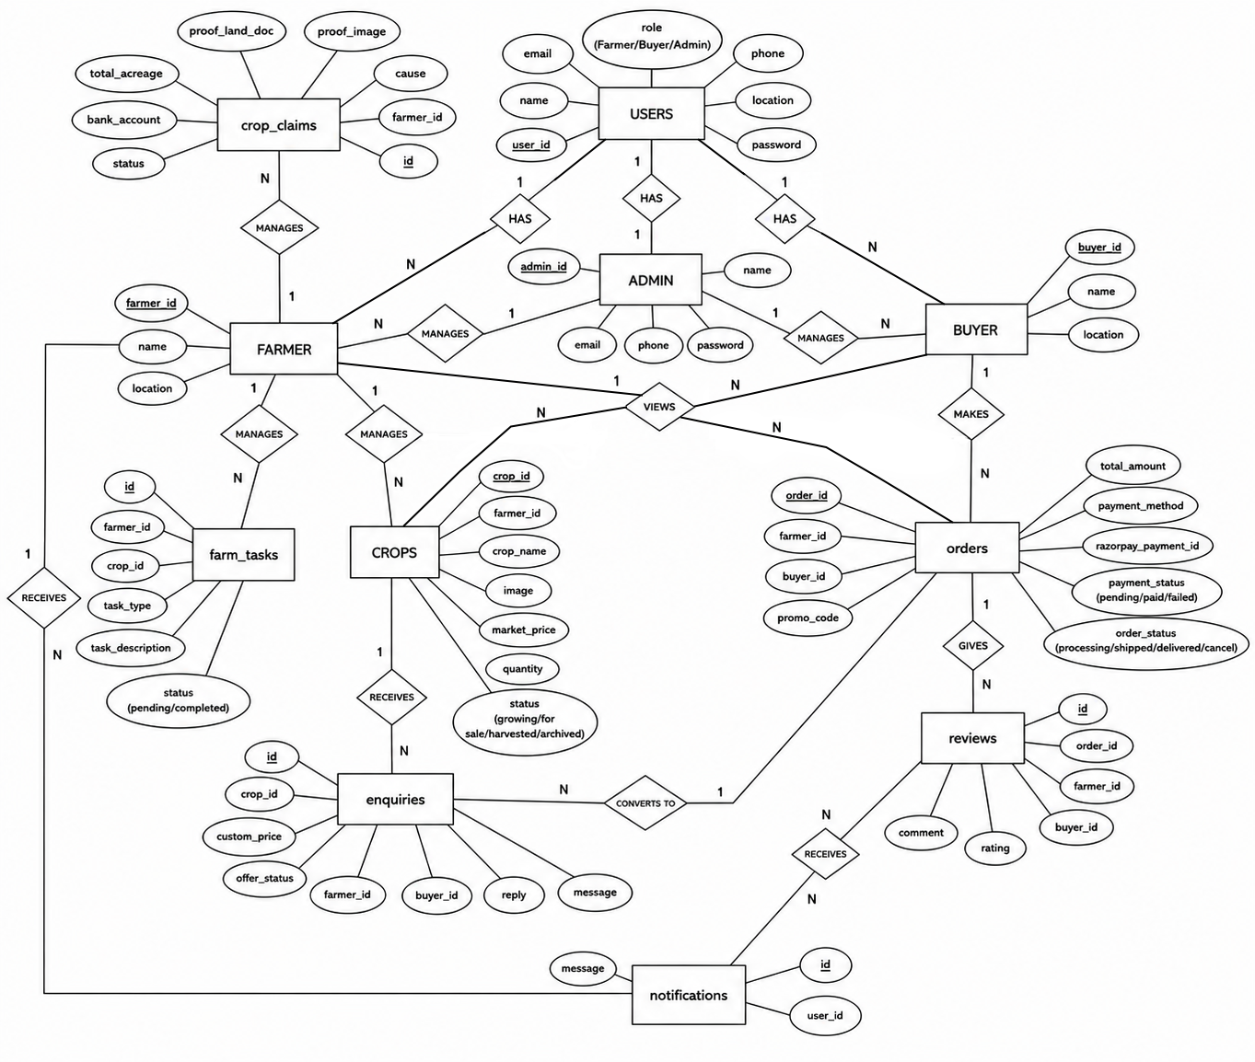
Figure 3.1.1: Entity relationship diagram
3.2 Data Flow Diagram(DFD)
- The ER Diagram shows the structure of the Farmogram database and the relationships between different entities in the system.
- The system includes a Database Design to map users, crops, and orders.

1. CONTEXT DIAGRAM
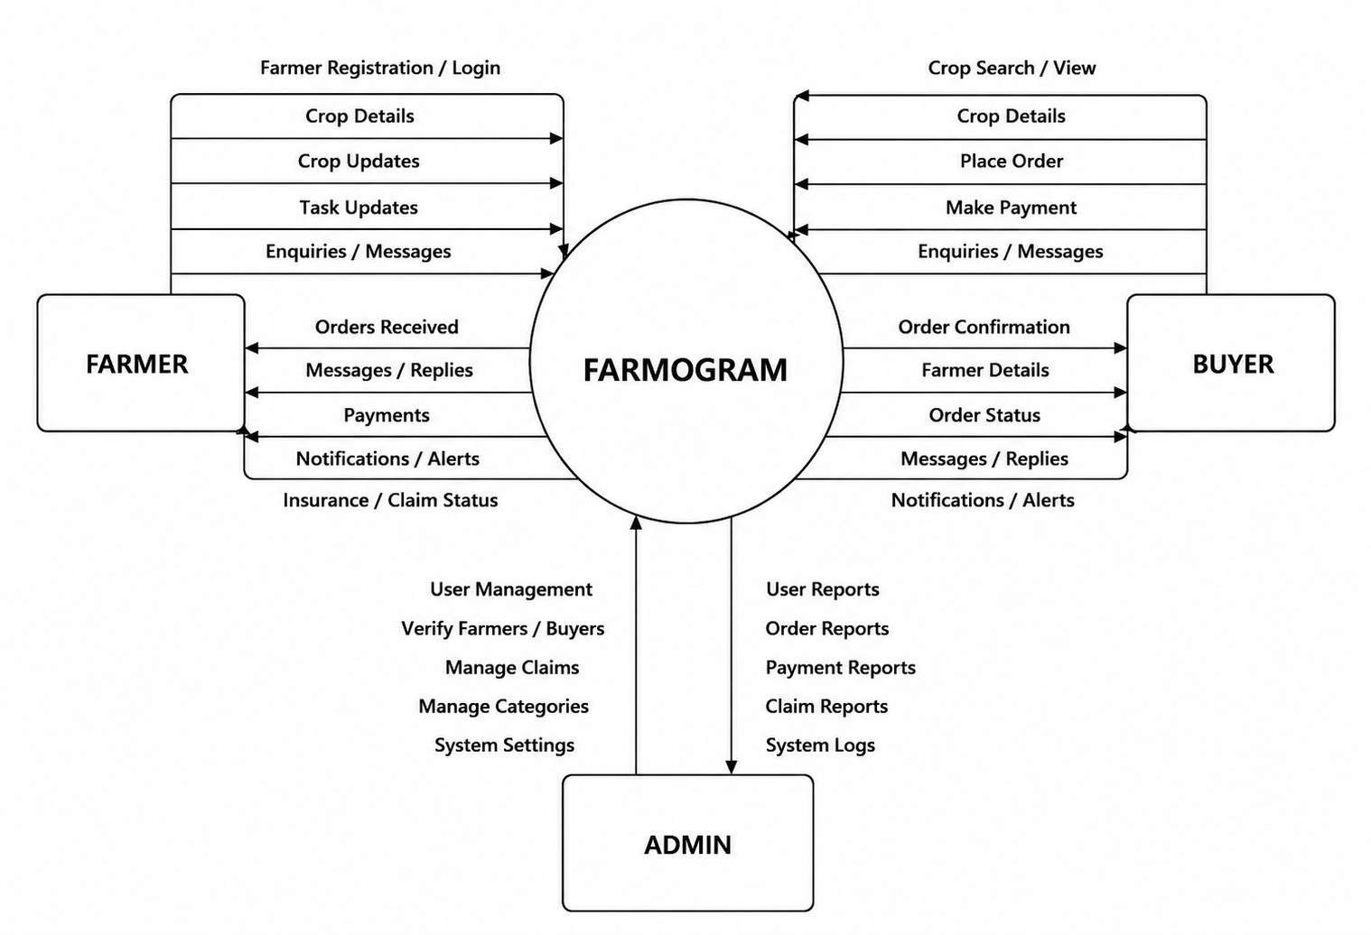
Figure 3.2.1: Data Flow diagram

2. DFD LEVEL 1: FOR FARMER

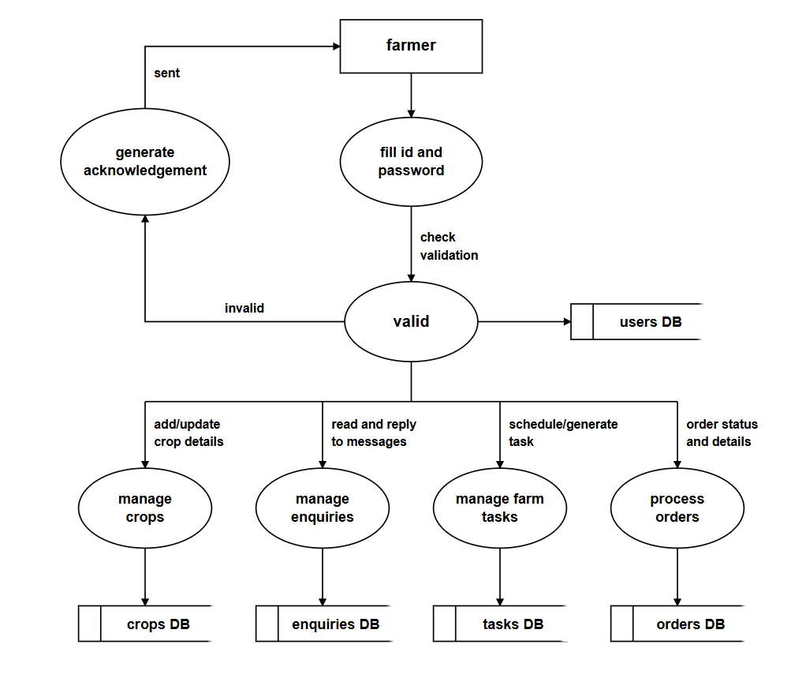

Figure 3.2.2: DFD Level 1 – For Farmer

3. DFD LEVEL 2: FOR FARMER
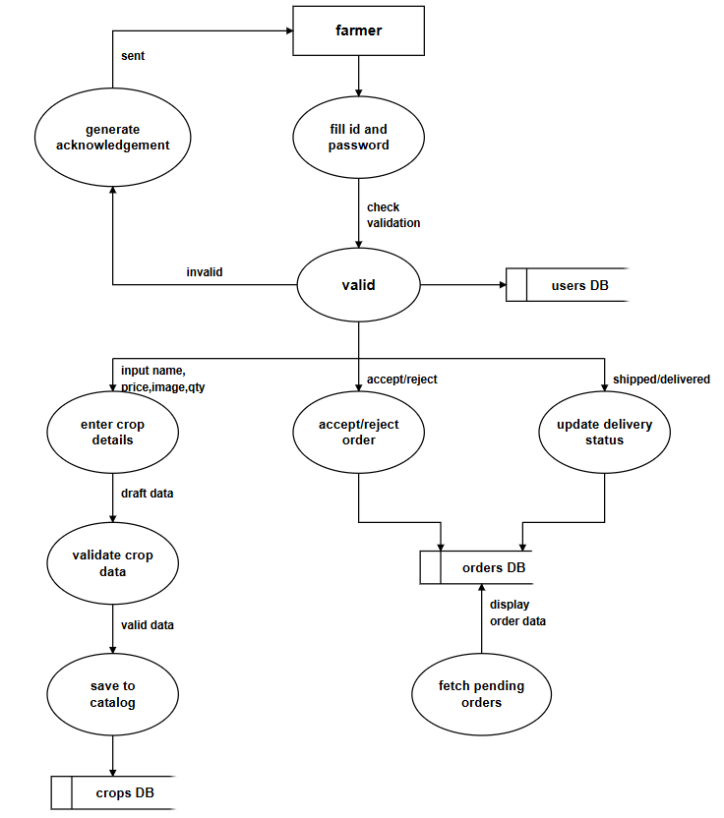

Figure 3.2.3: DFD Level 2 – For Farmer

4. DFD LEVEL 1: FOR BUYER
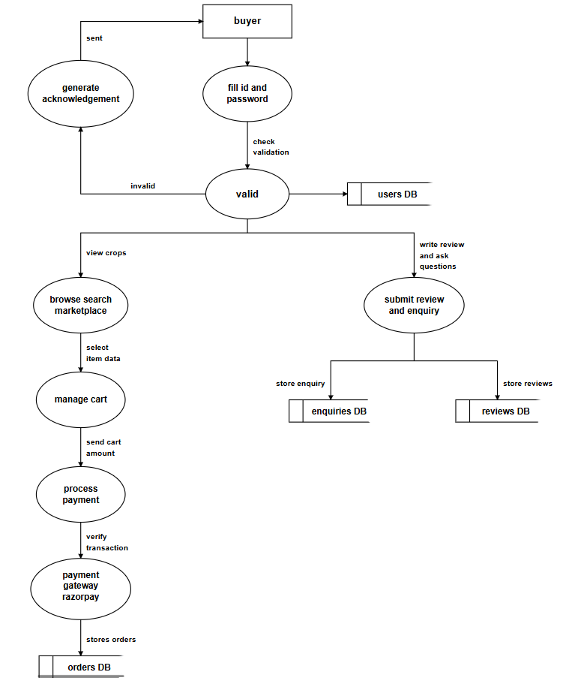

Figure 3.2.4: DFD Level 1 – For Buyer

5. DFD LEVEL 2: FOR BUYER
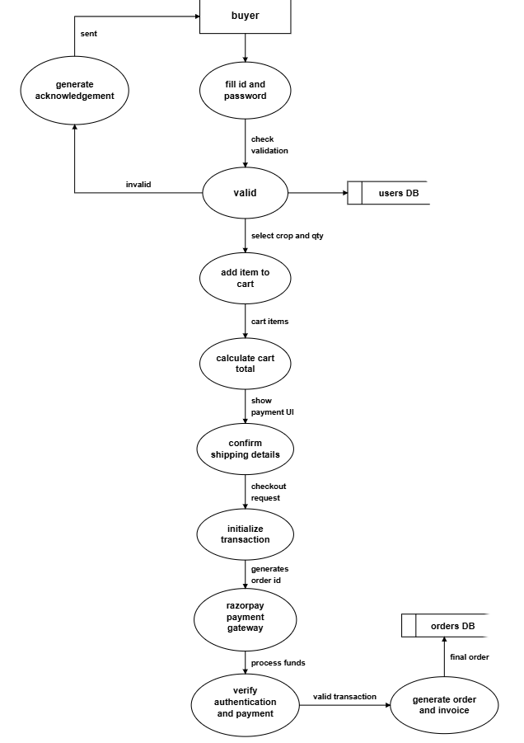

Figure 3.2.5: DFD Level 2 – For Buyer
6. DFD LEVEL 1: FOR ADMIN
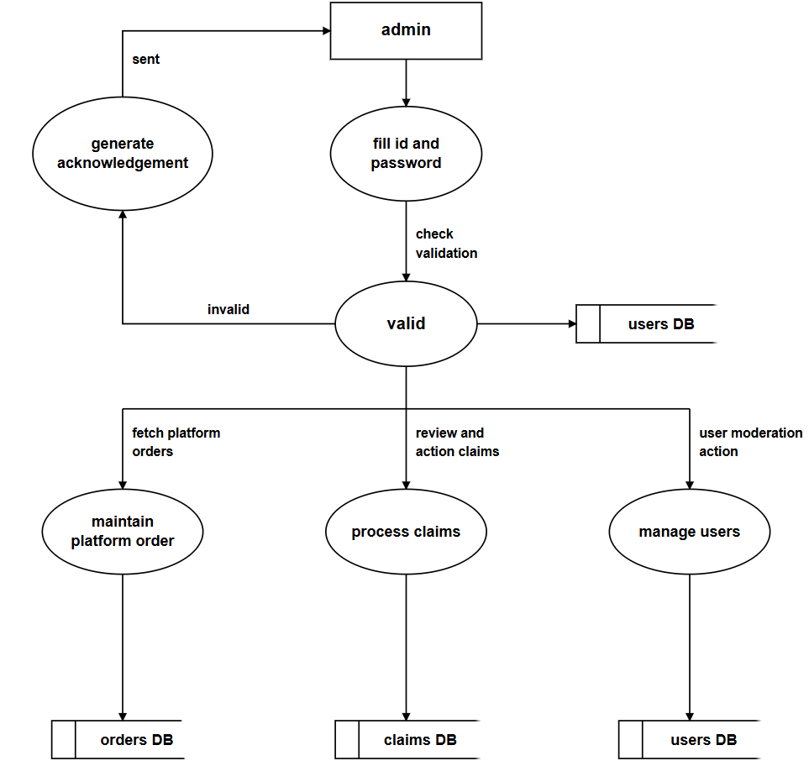

Figure 3.2.6: DFD Level 1 – For Admin

7. DFD LEVEL 2: FOR ADMIN
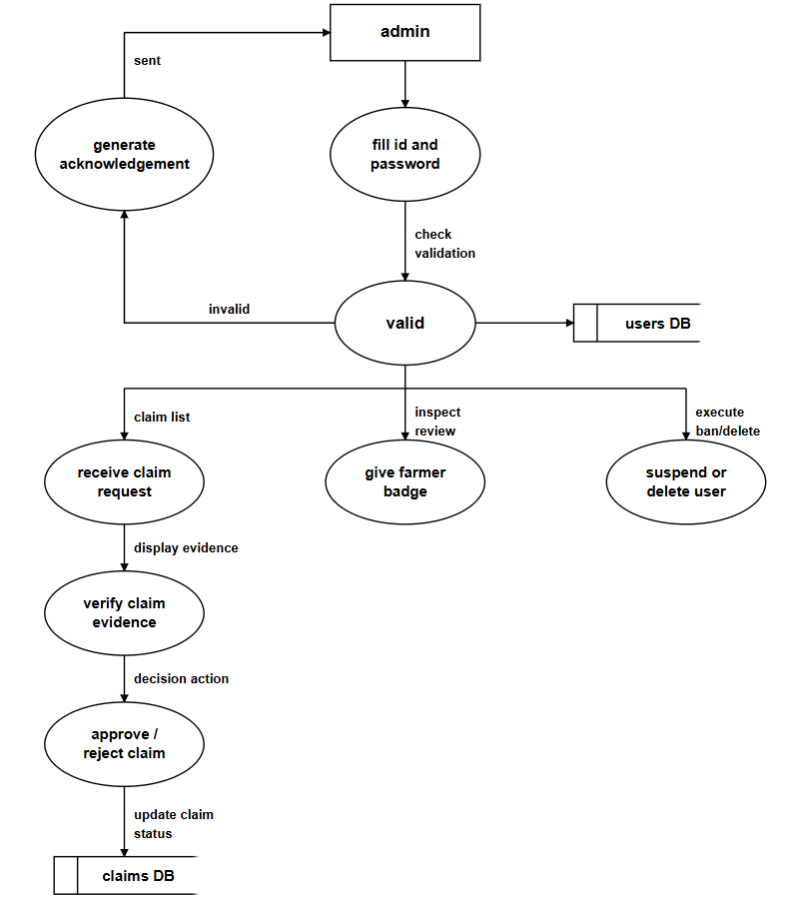

Figure 3.2.7: DFD Level 2 – For Admin

3.3 SCHEMA DIAGRAM
- The Schema Diagram represents the database tables, attributes, primary keys, and foreign key relationships used in the Farmogram system.
- It provides a detailed view of how data is stored and connected, ensuring efficient data management and smooth system operations.
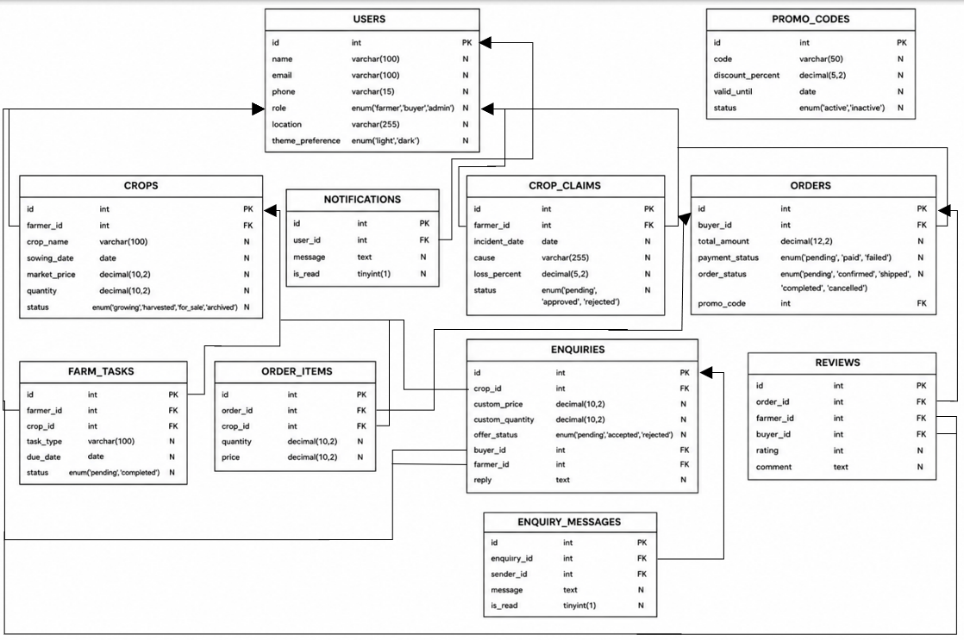
Figure 3.3.1: Schema Diagram

CHAPTER 4
TESTING AND IMPLIMENTATION

4.1 WHITE BOX TESTING
White Box Testing is a software testing technique that examines the internal code structure, logic, and program flow to ensure that all paths and conditions work correctly.
TEST CASE ID | COMPONENT | TEST SCENARIO / DESCRIPTION | EXPECTED RESULT | STATUS
WB-01 | Auth Logic | Verify password verification function during user authentication process. | System successfully matches entered password with encrypted password stored in database. | Pass
WB-02 | Database Schemas | Validate SQL query execution while inserting new crop details. | SQL query executes successfully without database errors or SQL injection vulnerability. | Pass
WB-03 | API Integration | Test data mapping and response handling from the AI API integration. | API response data is processed correctly and displayed properly in the system. | Pass
WB-04 | Session Management | Test session destruction process when an admin removes an active user. | System successfully invalidates the user session and logs the user out securely. | Pass
WB-05 | Backend Calculation | Verify cart subtotal and total amount calculation logic in the payment module. | System returns correct calculated values without calculation errors. | Pass
WB-07 | Enquiry Module | Test enquiry sending and messaging between buyer and farmer. | Messages and enquiries are delivered and displayed correctly. | Pass
WB-08 | Payment Module | Test payment processing and transaction status updates. | Payment status updates successfully after transaction completion. | Pass
Figure 4.1.1: White Box Testing
4.2 BLACK BOX TESTING
Tests the functionality of the system without examining the internal code structure.

TEST CASE ID | MODULE | TEST SCENARIO / DESCRIPTION | EXPECTED RESULT | STATUS
BB-01 | Authentication | Attempt login with unregistered email format. | System prevents submission and shows “Invalid email” format error. | Pass
BB-02 | Authentication | Attempt login with correct credentials. | System successfully authenticates and redirects user to their specific dashboard. | Pass
BB-03 | Farmer | Upload a crop image exceeding the 5MB limit. | System rejects the upload and displays a file size limit exceeded error. | Pass
BB-04 | Buyer | Add multiple distinct items to the cart simultaneously. | Cart badge updates dynamically without a full page reload (AJAX). | Pass
BB-05 | PWA | Turn off internet connection and reload the application. | Service worker detects offline state and serves the offline fallback page. | Pass
BB-06 | Crop Management | Add new crop details with valid inputs. | System stores crop information successfully in the database. | Pass
BB-07 | Enquiry Module | Send enquiry from buyer to farmer. | Enquiry message is delivered and displayed correctly. | Pass
BB-08 | Payment Module | Complete payment using online payment gateway. | Payment is processed successfully and order status is updated. | Pass
BB-09 | Notification System | Trigger order notification after successful purchase. | User receives notification instantly in the dashboard. | Pass
BB-10 | Insurance Claim | Submit crop damage claim with required documents. | System uploads claim details successfully for admin verification. | Pass
Figure 4.2.1: Black Box Testing

4.3 UNIT TESTING
Tests individual modules or functions separately to ensure they work correctly.

TEST CASE ID | COMPONENT TESTED | EXPECTED RESULT | STATUS
UT-01 | Password Validation | System rejects passwords shorter than 8 characters. | Pass
UT-02 | Cart Total Calculator | System correctly calculates the total price of all items in the cart. | Pass
UT-03 | Email Format Validation | System displays an error message for invalid email formats. | Pass
UT-04 | Crop Price Validation | System rejects negative or invalid crop prices entered by farmers. | Pass
UT-05 | Stock Quantity Check | System prevents buyers from adding quantity greater than available stock. | Pass
UT-06 | Login Authentication | System allows login only with valid username and password. | Pass
UT-07 | Task Status Update | System updates farming task status from pending to completed correctly. | Pass
UT-08 | Order Amount Calculation | System correctly calculates subtotal, tax, and final order amount. | Pass
UT-09 | Image Upload Validation | System accepts only valid image formats and limited file sizes. | Pass
UT-10 | Notification Trigger | System sends notifications successfully after important user actions. | Pass
Figure 4.3.1: Unit Testing

4.4 INTEGRATION TESTING
Tests the interaction between multiple modules to verify proper data flow and communication.

TEST CASE ID | INTEGRATION TESTED | EXPECTED RESULT | STATUS
IT-01 | Marketplace & Database | Products added to the database correctly appear in the marketplace interface. | Pass
IT-02 | Registration & Database | New user details are successfully stored in the users table after registration. | Pass
IT-03 | Cart & Checkout System | Cart details are successfully transferred to the checkout confirmation page. | Pass
IT-04 | Payment Gateway & Orders | Successful payment automatically updates the order status in the database. | Pass
IT-05 | Image Upload & Storage | Uploaded crop images are stored on the server and linked correctly in the database. | Pass
IT-06 | Farmer Module & Notifications | Notifications are sent successfully when farmers add or update crop details. | Pass
IT-07 | Buyer & Enquiry Module | Buyer enquiries are correctly delivered to the farmer dashboard. | Pass
IT-08 | AI Assistant & Crop Module | Uploaded crop images are processed successfully for AI-based disease detection. | Pass
IT-09 | Insurance Claims & Admin Module | Submitted crop claims are displayed correctly in the admin verification panel. | Pass
IT-10 | Order Management & Payment Module | Order details and payment information are synchronized correctly after checkout. | Pass
Figure 4.4.1: Integration Testing

4.5 SYSTEM TESTING
Tests the complete system as a whole to ensure all requirements are met.

TEST CASE ID | SYSTEM FLOW TESTED | EXPECTED RESULT | STATUS
ST-01 | End-to-End Purchase Flow | User can log in, add crops to cart, and successfully place an order. | Pass
ST-02 | Farmer Crop Listing | Farmer can log in, upload crop details, and view them successfully in the marketplace. | Pass
ST-03 | Role-Based Routing | Buyers, Farmers, and Admins are redirected to their respective dashboards after login. | Pass
ST-04 | Order History Retrieval | Users can successfully view their previous orders and transaction details. | Pass
ST-05 | Admin Dashboard Analytics | Admin can monitor users, orders, and platform statistics correctly. | Pass
ST-06 | Crop Insurance Claim Flow | Farmer can submit crop damage claims and admin can review them successfully. | Pass
ST-07 | AI Crop Disease Detection | Farmers can upload crop images and receive disease detection results correctly. | Pass
ST-08 | Notification and Alert System | Users receive notifications for orders, payments, and farming tasks properly. | Pass
ST-09 | Payment and Checkout Process | Payment gateway processes transactions successfully and updates order status. | Pass
ST-10 | Multi-Language Support | Users can switch languages and access the system without interface issues. | Pass
Figure 4.5.1: System Testing

4.6 ACCEPTANCE TESTING
Verifies whether the system satisfies user requirements and is ready for deployment.

TEST CASE ID | ACCEPTANCE CRITERIA | EXPECTED RESULT | STATUS
AT-01 | User Friendliness | Farmers with basic technical knowledge can easily use the system without assistance. | Pass
AT-02 | Mobile Accessibility | Users can access and use the platform smoothly on mobile devices. | Pass
AT-03 | Search and Filter Usability | Buyers can easily search and filter crops based on category, price, and location. | Pass
AT-04 | Rural Network Performance | The system loads and functions properly even with low internet connectivity. | Pass
AT-05 | Language Support | Users can understand and operate the system easily using regional language options. | Pass
AT-06 | Farmer Dashboard Usability | Farmers can manage crops, tasks, and orders without confusion. | Pass
AT-07 | Buyer Purchase Experience | Buyers can complete crop purchasing and payment processes successfully. | Pass
AT-08 | AI Assistance Feature | Farmers can use AI-based crop suggestions and disease detection easily. | Pass
AT-09 | Notification and Alerts | Users receive timely notifications for orders, tasks, and payments. | Pass
AT-10 | Overall System Performance | The complete Farmogram system works smoothly and meets user requirements effectively. | Pass
Figure 4.6.1: Acceptance Testing

4.7 VALIDATION TESTING
Ensures that the developed system meets the intended user needs and project objectives.

TEST CASE ID | VALIDATION GOAL | EXPECTED RESULT | STATUS
VT-01 | Direct Farmer–Buyer Connection | The platform successfully allows direct communication and crop sales between farmers and buyers. | Pass
VT-02 | Middleman Reduction | Farmers receive better profits through direct selling without broker involvement. | Pass
VT-03 | Financial Support for Farmers | Advance crop booking helps farmers receive financial support during cultivation. | Pass
VT-04 | Secure Transactions | Payment transactions are processed securely and order details are updated correctly. | Pass
VT-05 | Crop Management Efficiency | Farmers can manage crop details, schedules, and farming activities effectively. | Pass
VT-06 | AI-Based Farming Assistance | Farmers receive useful crop disease detection and farming suggestions from the AI system. | Pass
VT-07 | Multi-Language Accessibility | Regional language support makes the platform easier for rural farmers to use. | Pass
VT-08 | Order and Payment Transparency | Buyers and farmers can track orders and payments without confusion. | Pass
VT-09 | Insurance Claim Support | Farmers can successfully submit crop damage claims and receive proper verification support. | Pass
VT-10 | Overall System Reliability | The Farmogram platform functions smoothly and fulfills the objectives of the project. | Pass
Figure 4.7.1: Validation Testing

CHAPTER 5
SCREENSHOTS

1. INDEX PAGE
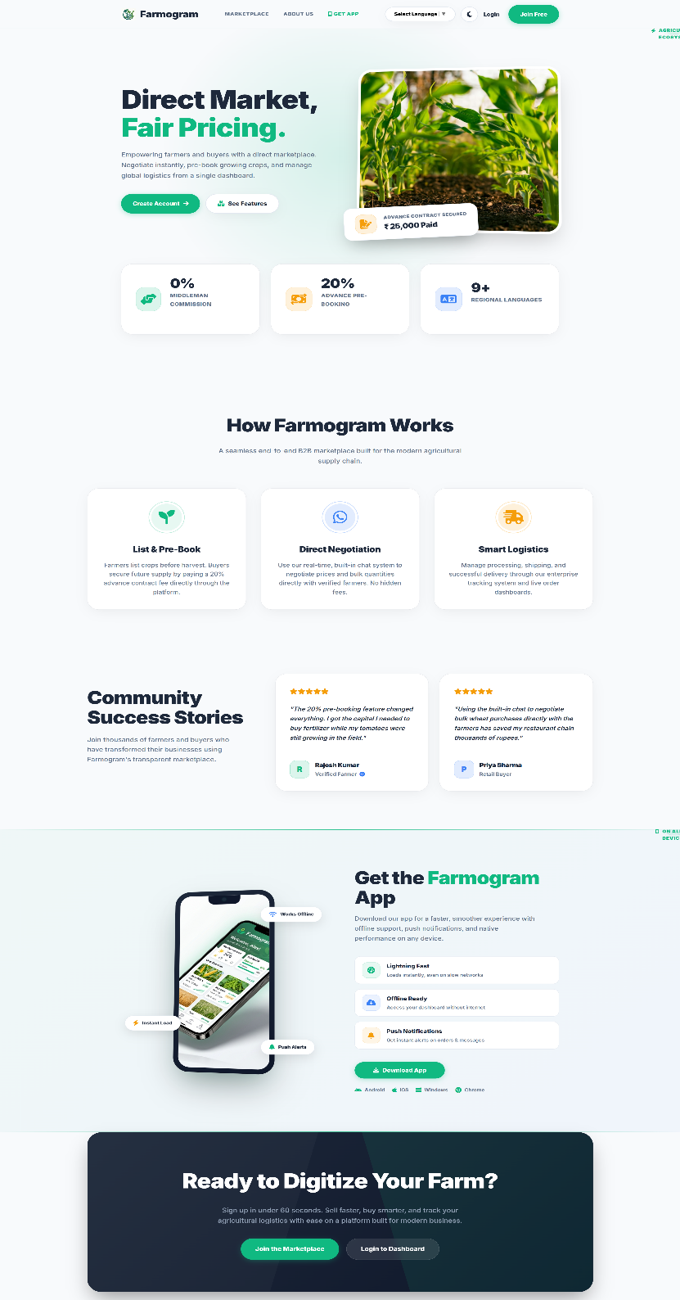

Figure 5.1.1: Index Page
2. FARMER REGISTER
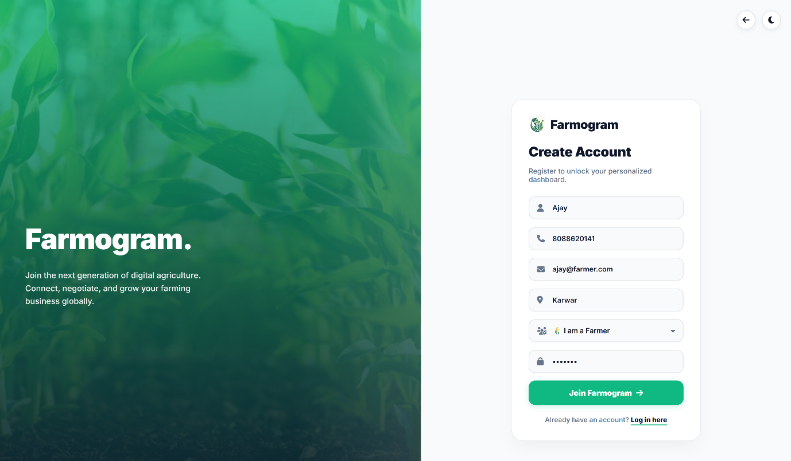

Figure 5.1.2: Farmer Registration
3. FARMER LOGIN
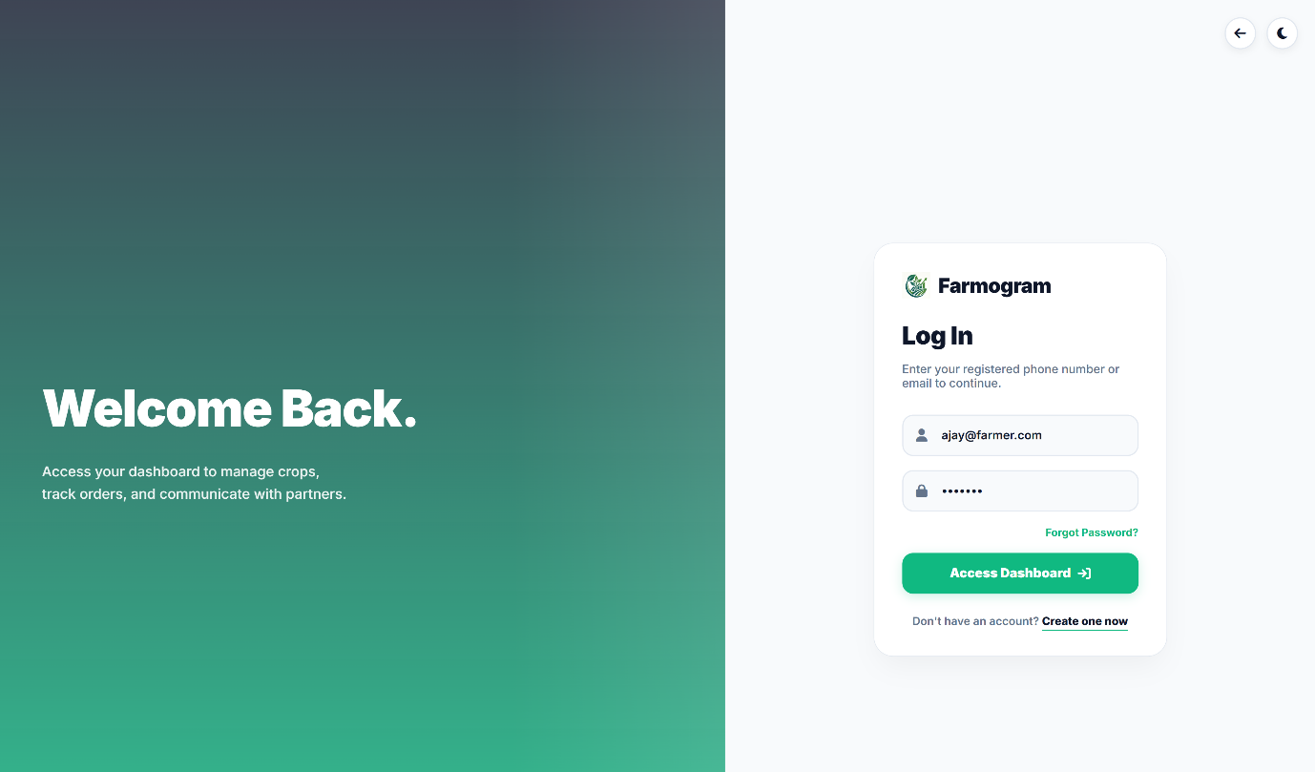
Figure 5.1.3: Farmer Login
4. FARMER DASHBOARD
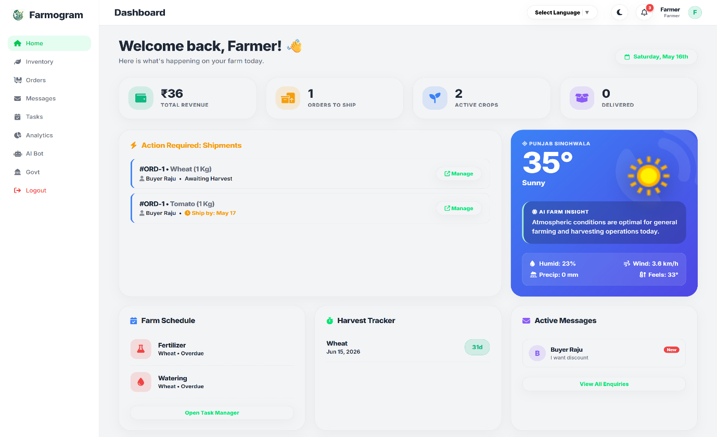

Figure 5.1.4: Farmer Dashboard
5. FARMER INVENTORY
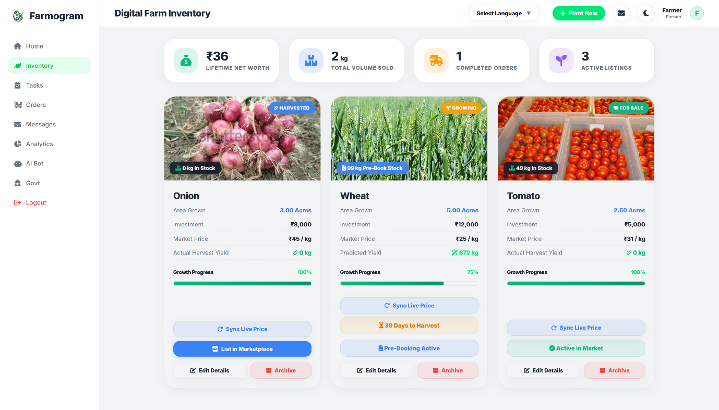

Figure 5.1.5: Farmer Inventory
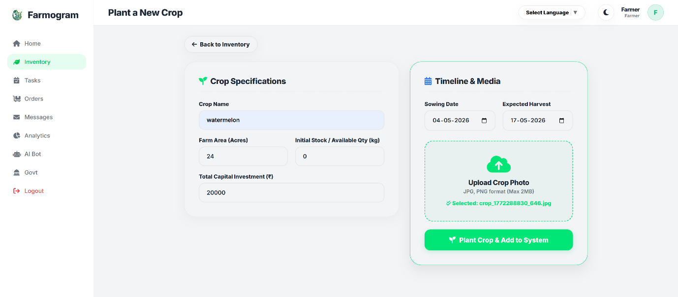
6. FARMER ADDING CROPS
Figure 5.1.6: Farmer crops listing

7. FARMER VIEWING ORDERS
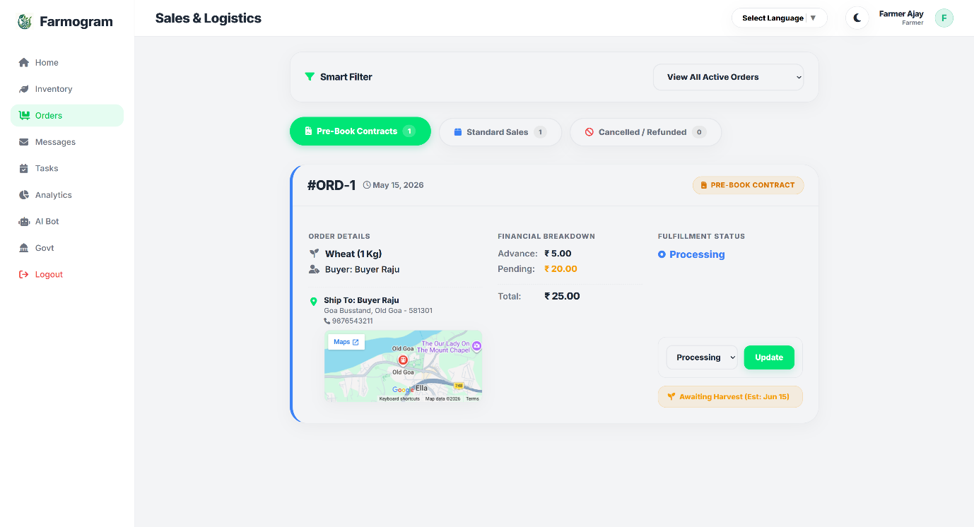

Figure 5.1.7: View Order

8. FARMER VIEWING ENQUIRIES
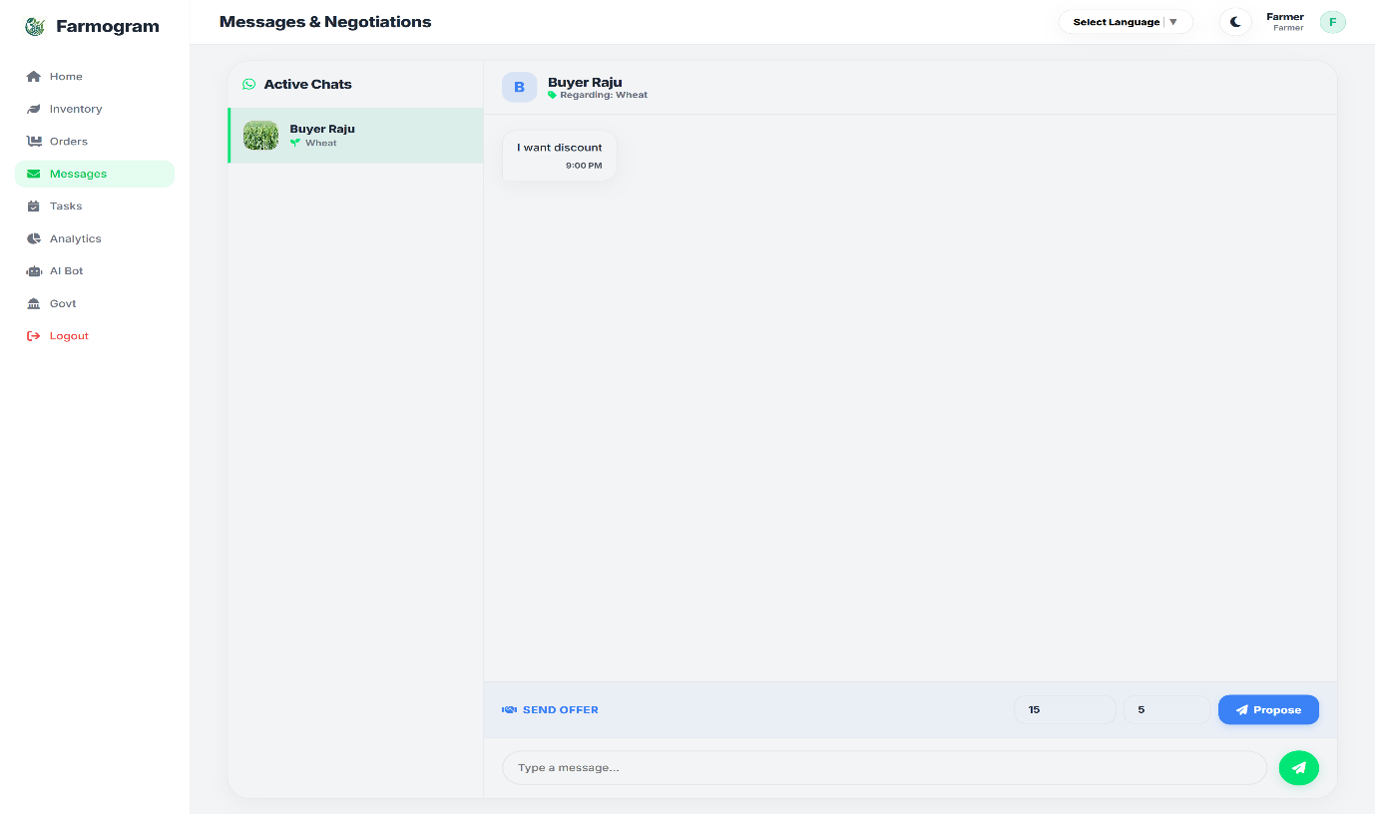

Figure 5.1.8: view Enquiries

9. FARMER TASKS
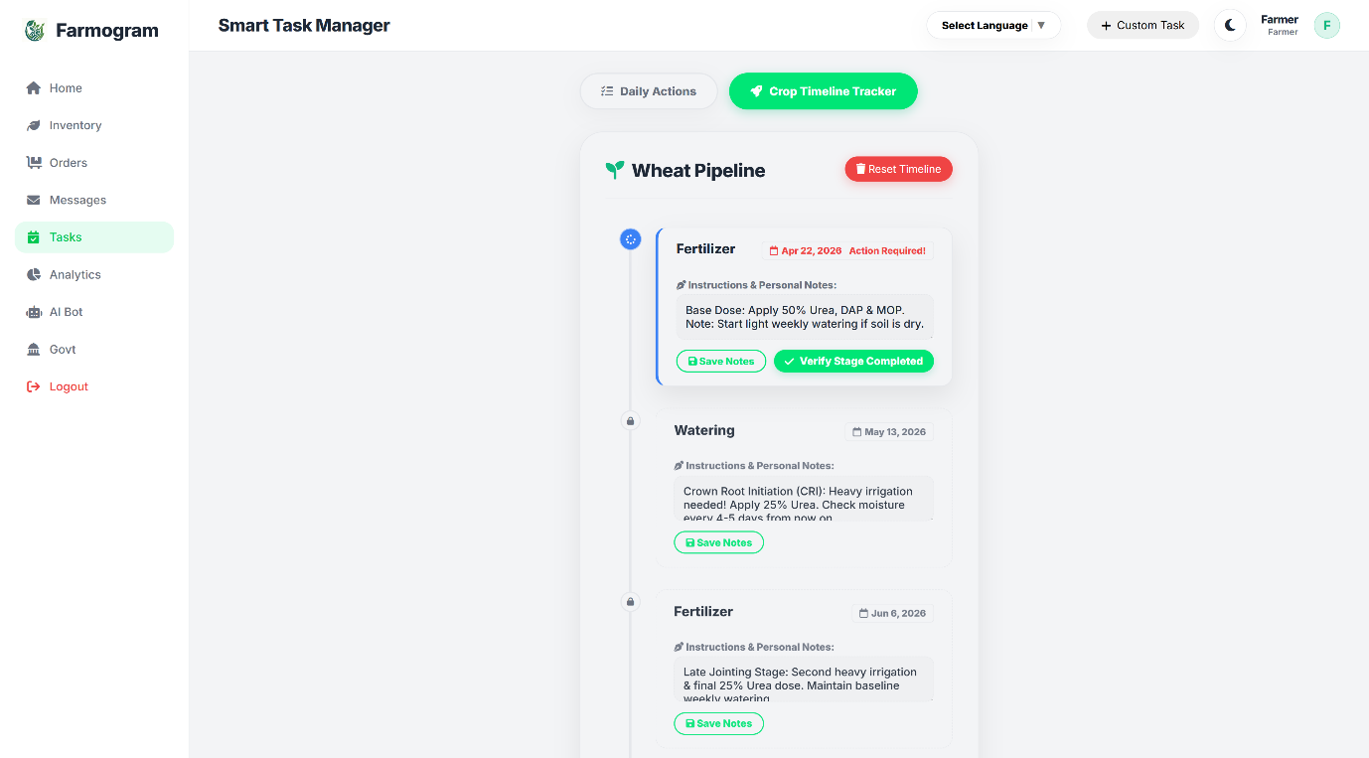

Figure 5.1.9: Farm Task
10. FARMER ANALYTICS
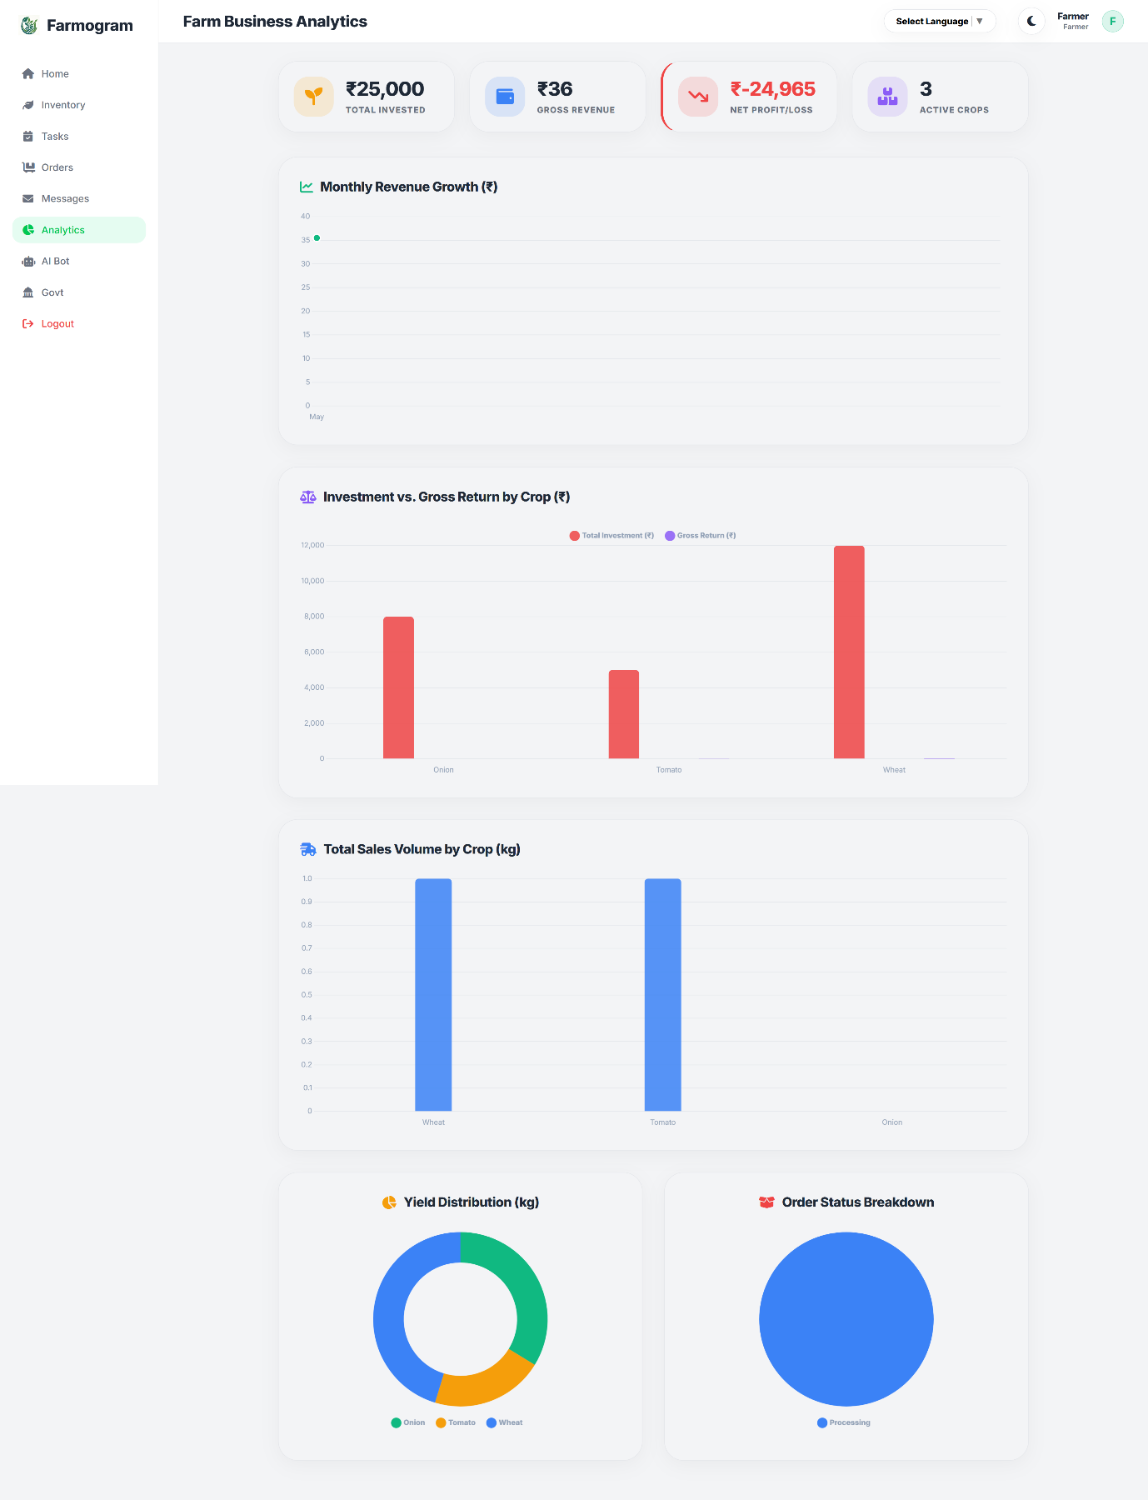

Figure 5.1.10: Farmer Analytics

11. FARMER ASSISTANT
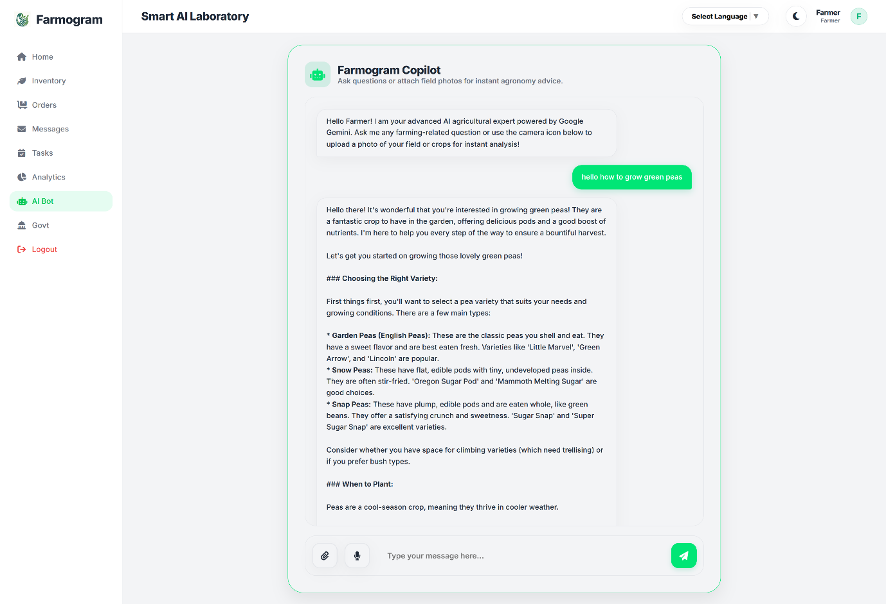

Figure 5.1.11: AI assistant
12. SCHEMES
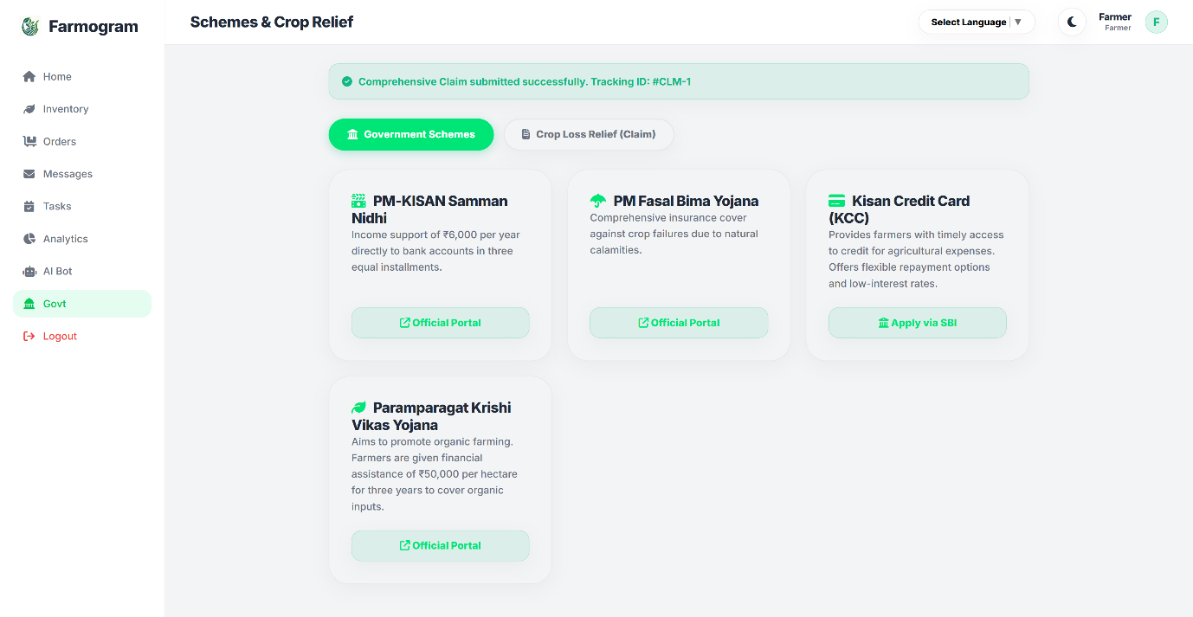

Figure 5.1.12: Farmer Schemes

13. CROP LOSS CLAIMS
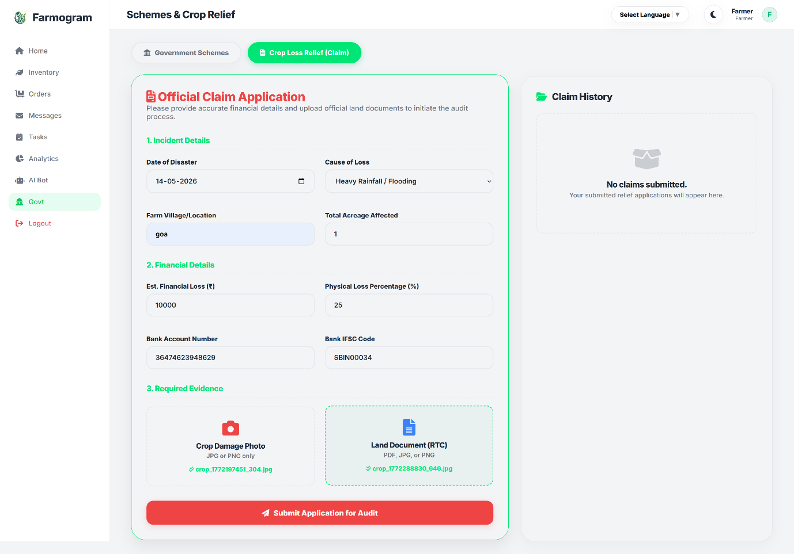

Figure 5.1.13: crop loss claims
14. CLAIM STATUS
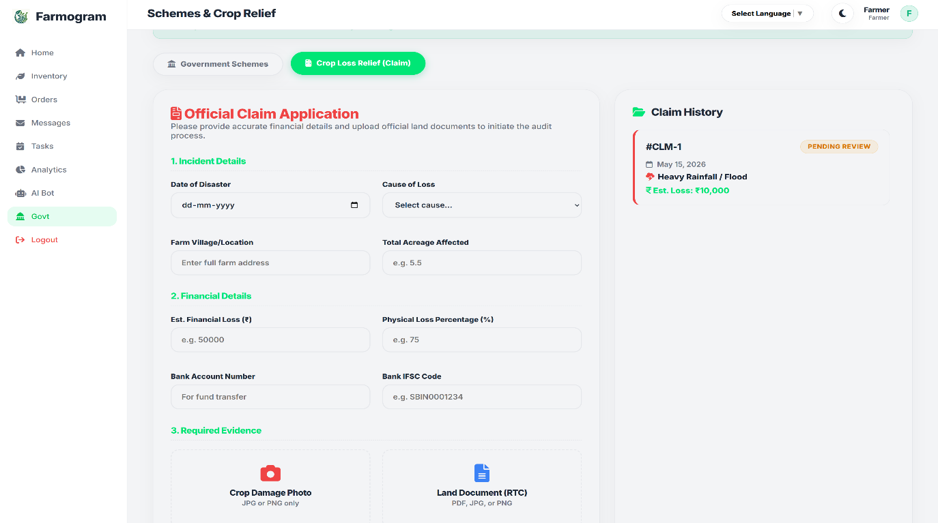

Figure 5.1.14: claim status
15. BUYER REGISTARATION
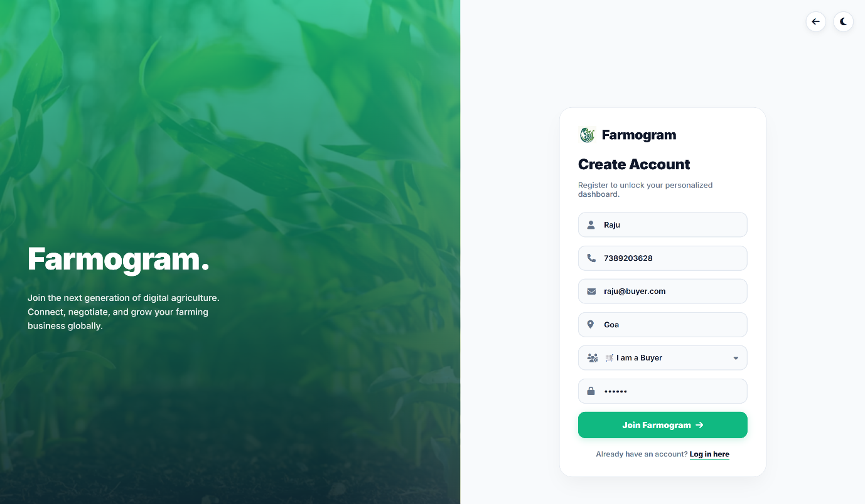

Figure 5.1.15: Buyer Registration

16. BUYER LOGIN
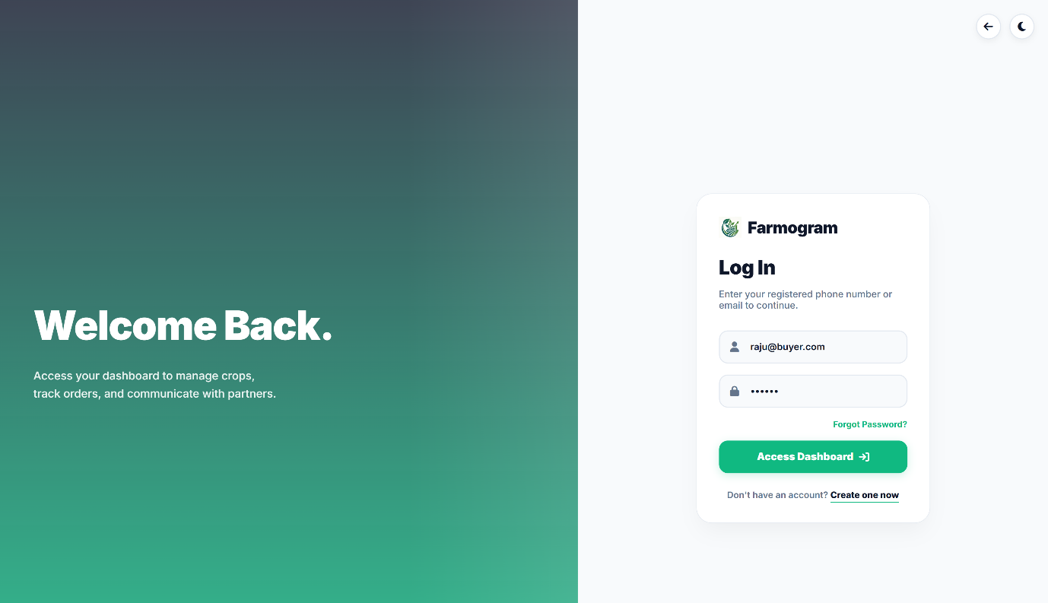

Figure 5.1.16: Buyer Login
17. MARKETPLACE
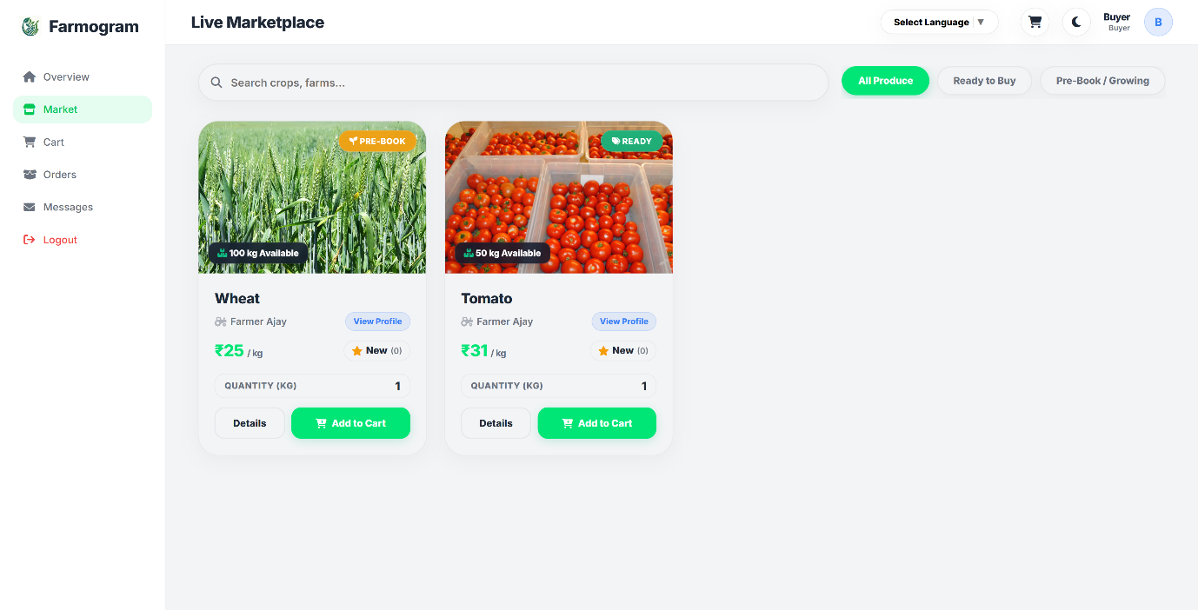

Figure 5.1.17: Marketplace

18. NEGOTIATE / CROP DETAILS
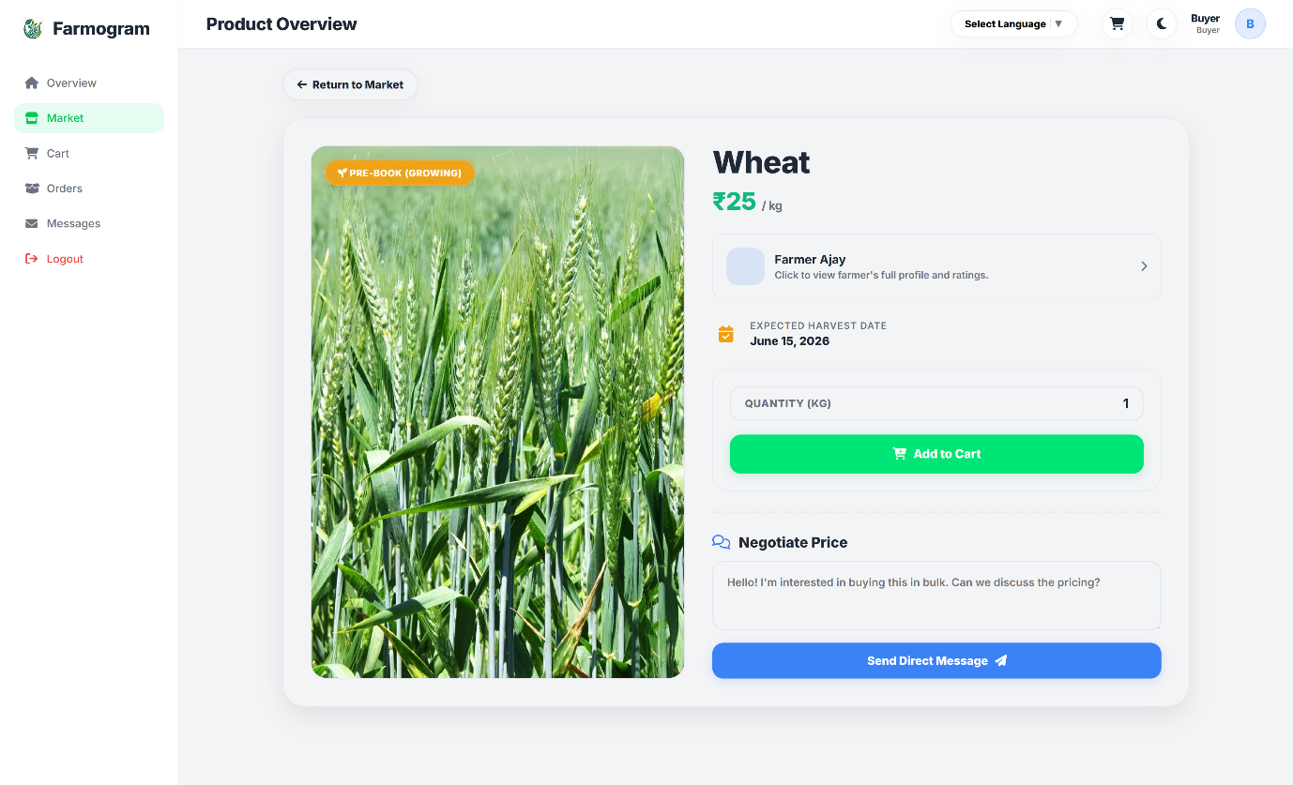

Figure 5.1.18: Crop Details
19. BUYER CART
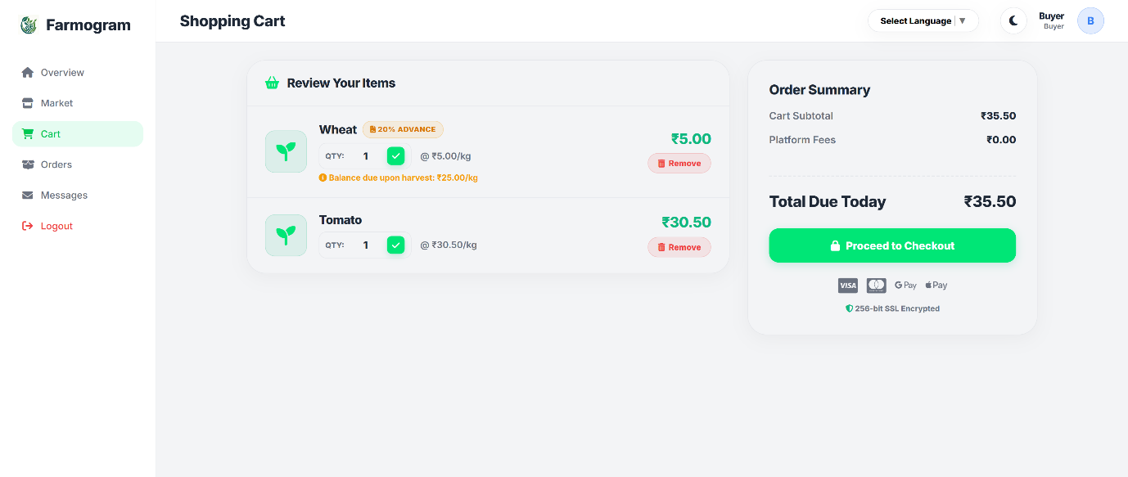

Figure 5.1.19: Cart

20. CHECKOUT
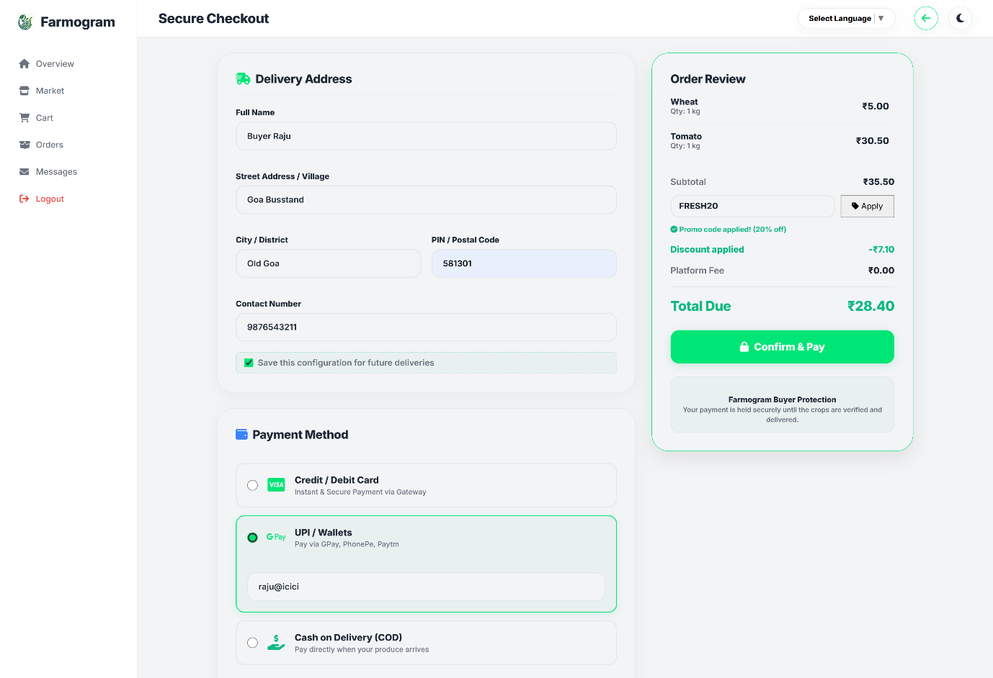

Figure 5.1.20: Checkout

21. BUYER ORDERS
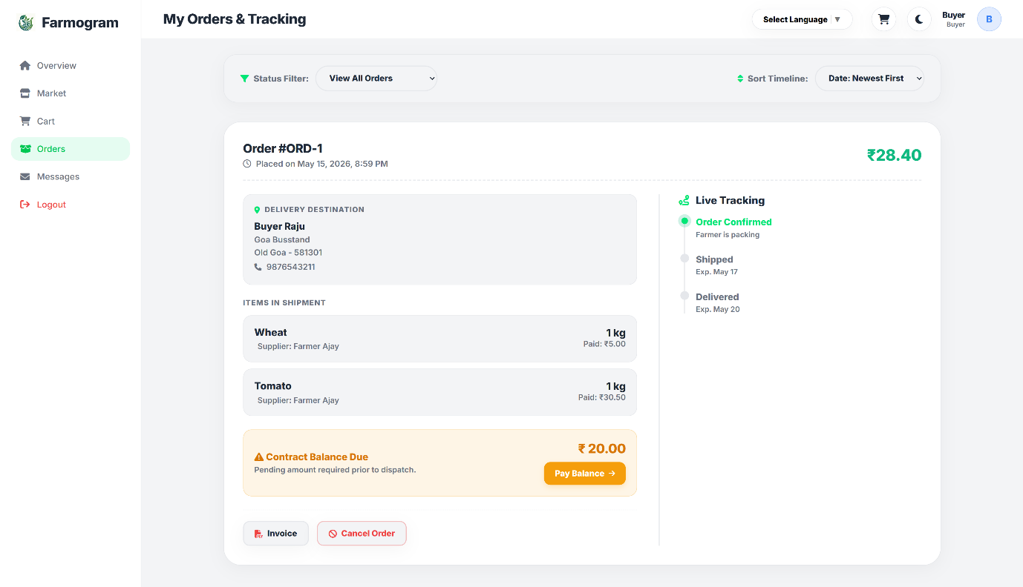

Figure 5.1.21: Buyer Orders

22. ENQUIRIES
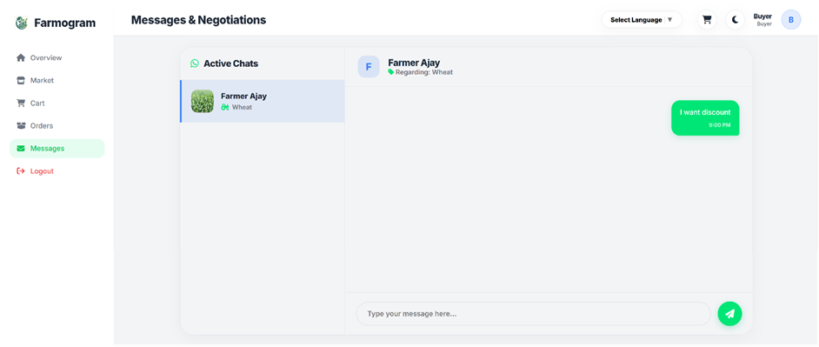
Figure 5.1.22: Messages

23. ACCEPTING FARMER OFFER
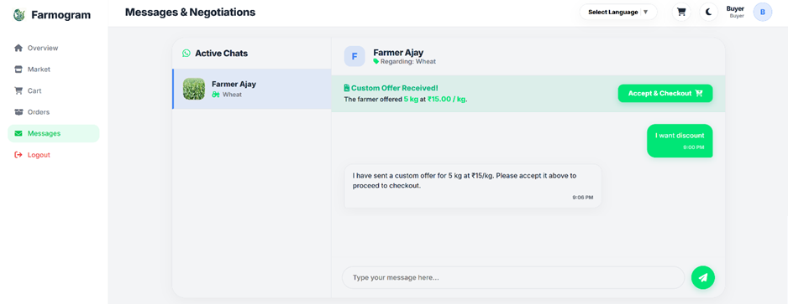

Figure 5.1.23: Offering Price

24. BUYER DASHBOARD
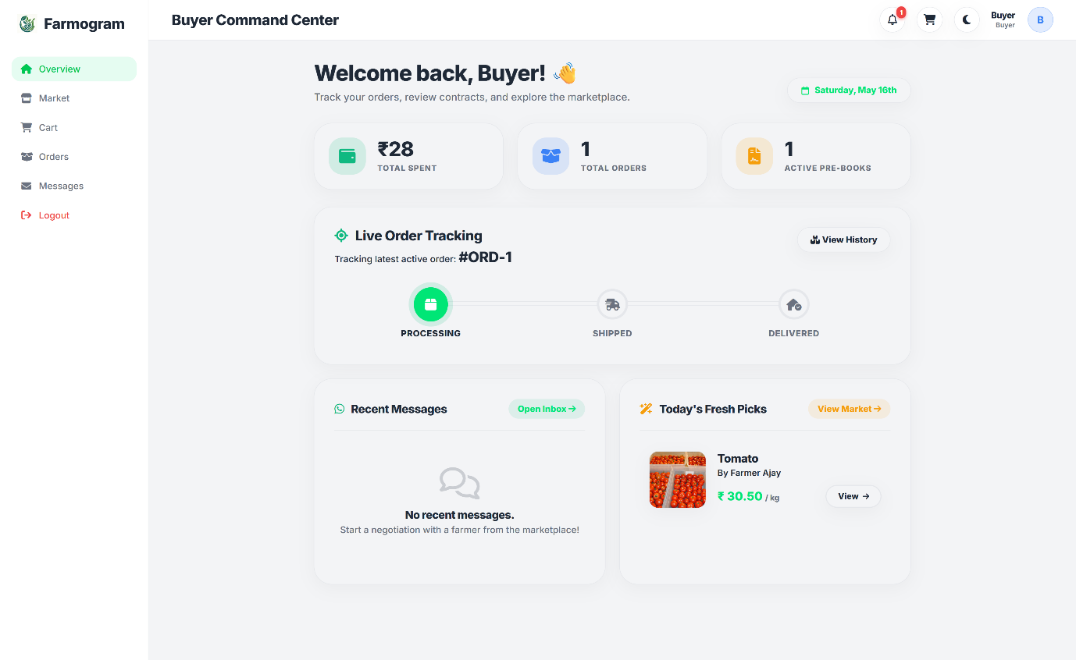

Figure 5.1.24: Buyer Dashboard

25. ADMIN LOGIN
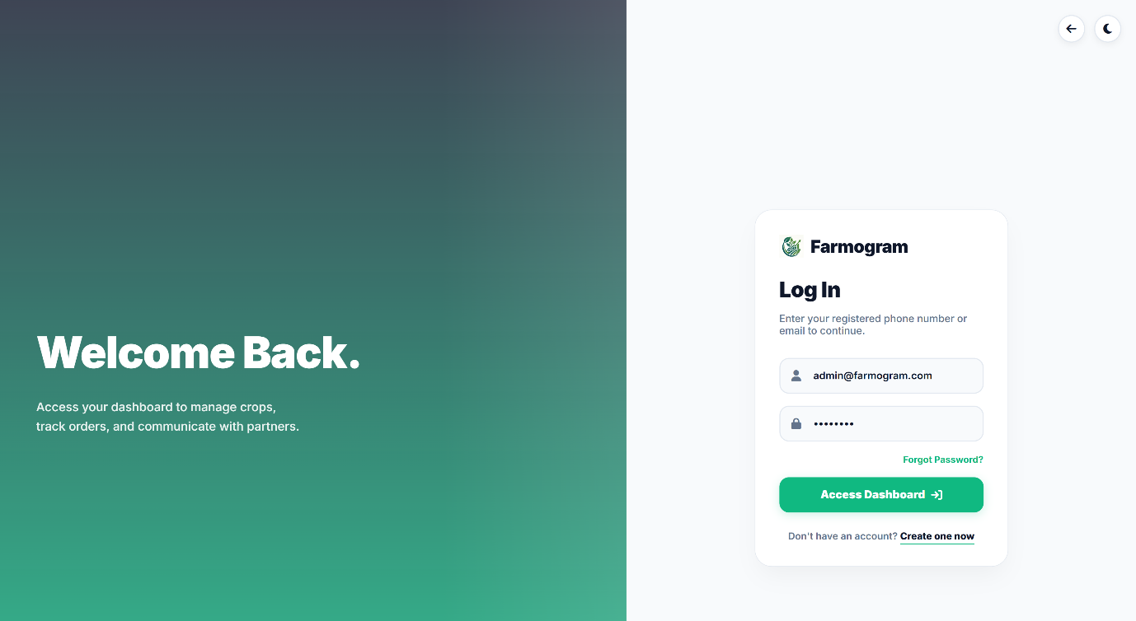

Figure 5.1.25: Admin Login

26. ADMIN DASHBOARD
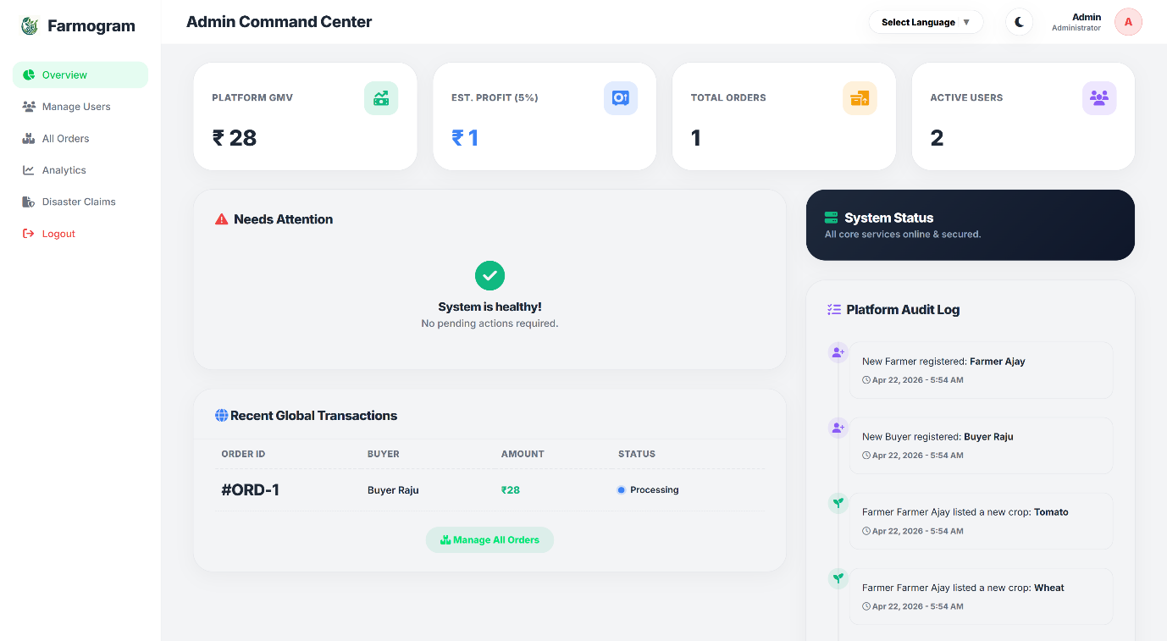

Figure 5.1.26: Admin Dashboard

27. MANAGING FARMERS
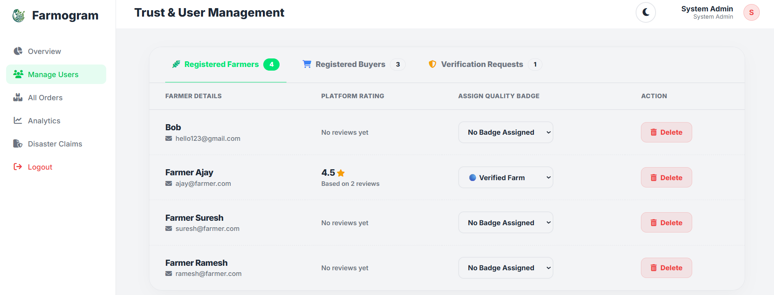

Figure 5.1.27: View Farmers
28. MANAGING BUYERS
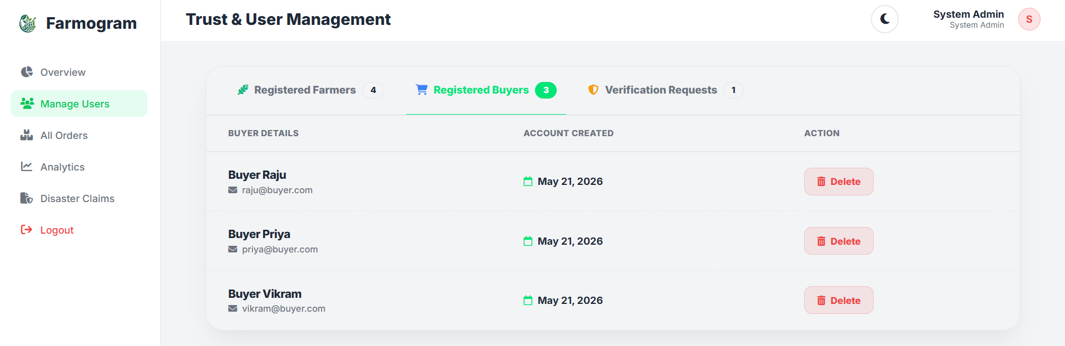

Figure 5.1.28: View Buyers
29. FARMER VERIRICATION REQUEST
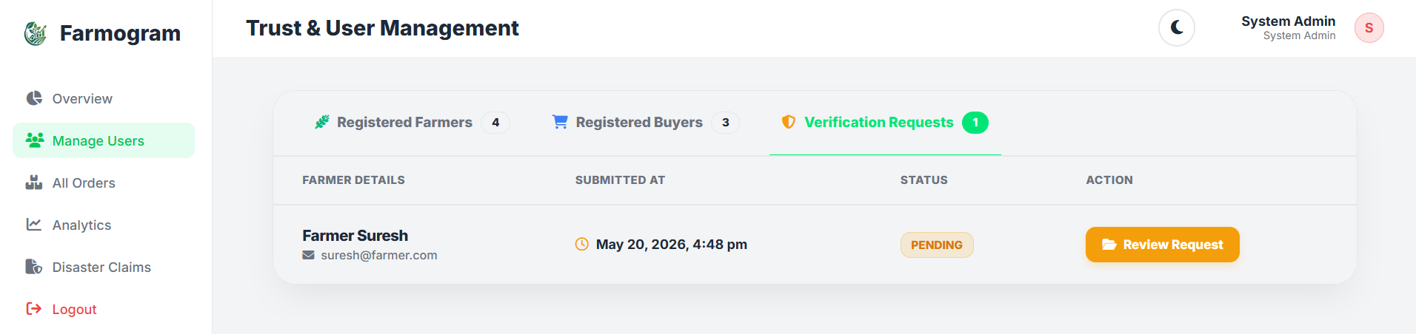

Figure 5.1.29: Account Verification

30. PLATFORM ORDERS
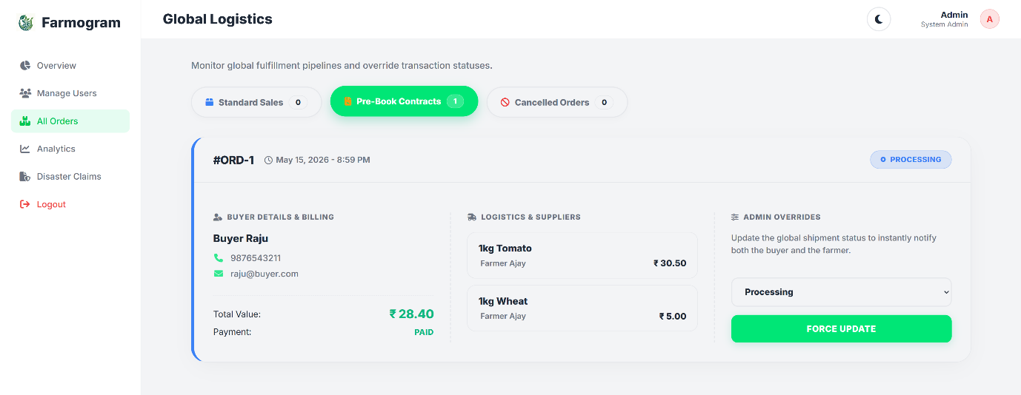

Figure 5.1.30: Orders

31. PLATFORM ANALYTICS
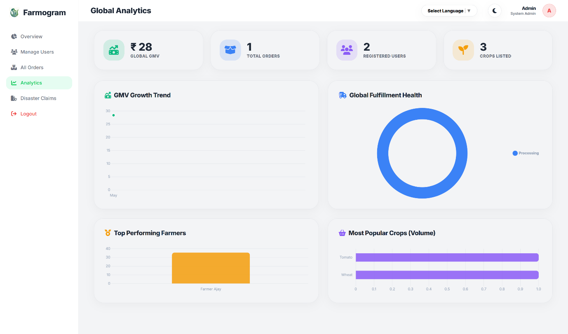

Figure 5.1.31: Analytics

32. CROP CLAIMS REQUESTS
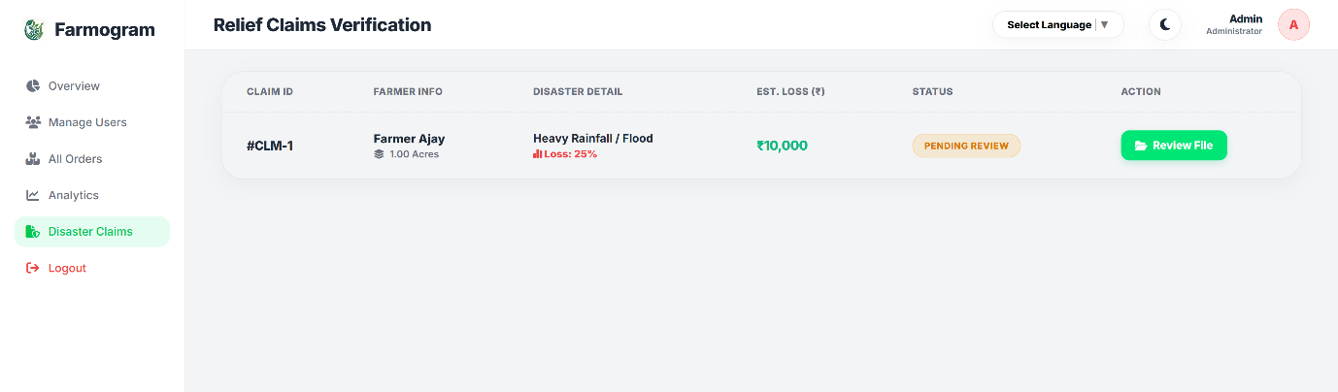

Figure 5.1.32: Loss Claim Request

33. VERIFY CLAIMS
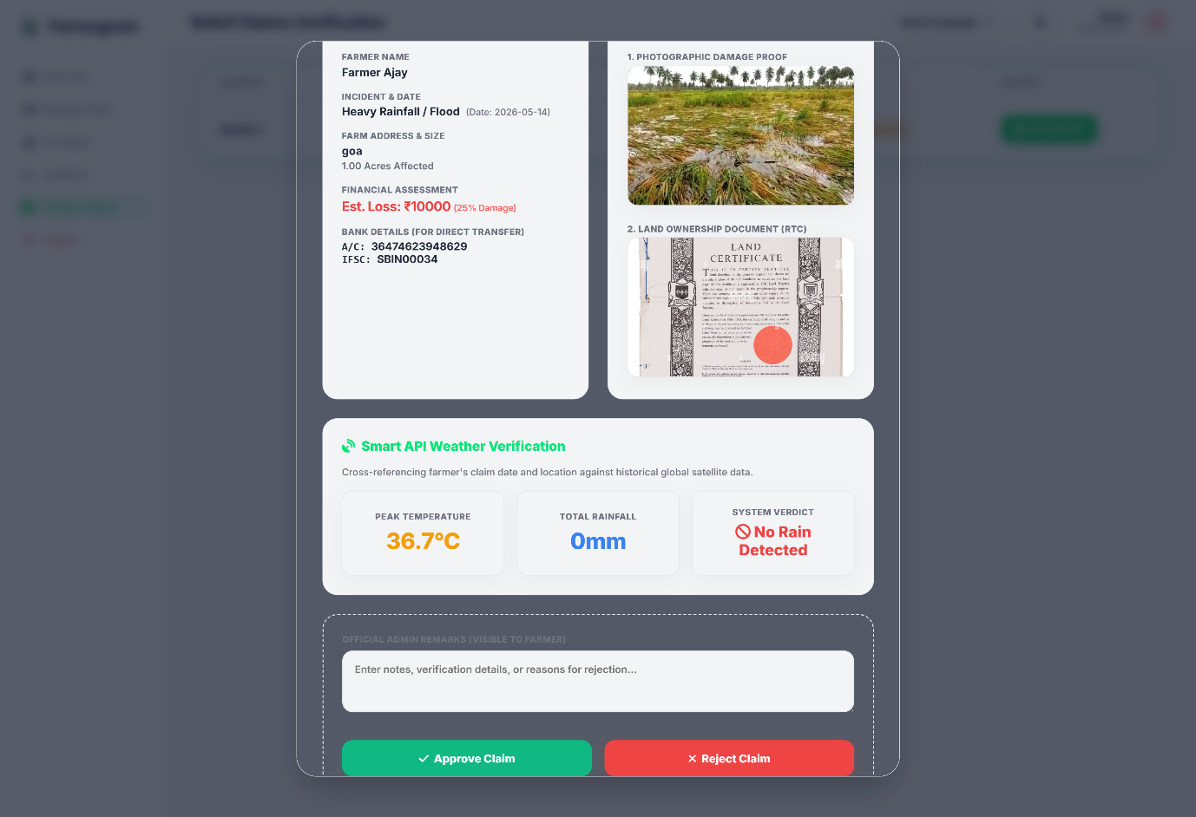

Figure 5.1.33: Verify claims

CONCLUSION

The Farmogram system has been successfully developed as a web-based platform to modernize the traditional agricultural ecosystem. The project focuses on solving major problems faced by farmers, such as dependency on middlemen, lack of market transparency, limited access to digital tools, and financial difficulties during crop cultivation. By providing a centralized platform, Farmogram enables direct interaction between farmers and buyers, ensuring fair pricing, better communication, and efficient transaction management.
The system integrates multiple modules such as crop management, enquiry and communication, order and payment processing, task management, and crop insurance claims, which together help farmers manage their activities effectively. Smart features like notifications, weather updates, crop monitoring, and AI-based assistance support farmers in making better farming decisions and improving productivity. Buyers can directly browse crops, negotiate prices, place orders, and track their purchases through the platform, creating a transparent and reliable agricultural marketplace.
One of the important achievements of the project is the implementation of the advance crop booking system, where buyers can pre-book crops by paying a partial amount during the cultivation stage. This helps farmers receive financial support before harvest and reduces their dependency on loans. The AI-based crop diagnostics feature also helps farmers identify crop diseases and receive suggestions for treatments, making farming more efficient and technology-driven.
The system also improves communication between farmers and buyers through real-time enquiry and messaging features. In addition, the crop insurance claim module simplifies the process of reporting crop damage and requesting financial assistance. The support for multiple regional languages further makes the platform easy to use for rural farmers.
Overall, Farmogram demonstrates how modern technology can be used to improve agricultural practices and support farmers through digital solutions. The project successfully achieves its objectives and provides a strong foundation for future improvements such as mobile applications, advanced AI integration, smart farming technologies, and location-based services. With further development, Farmogram has the potential to become a reliable and scalable digital platform that improves productivity, transparency, and profitability in the agricultural sector.

FUTURE SCOPE

1. Advanced API Optimization and Offline AI Support
Farmogram can be enhanced by reducing dependency on third-party APIs and introducing offline capabilities.
- Offline AI Features: Basic AI assistance and crop recommendations can work without internet access using local models.
- Efficient API Management: Smart caching and optimized API usage can reduce operational costs and rate-limit issues during large-scale usage.

2. Enhanced Voice Assistant Compatibility
The voice assistant feature can be improved for broader accessibility across devices.
- Cross-Platform Support: Compatibility can be expanded to older browsers and low-end smartphones.
- Multilingual Voice Assistance: Farmers can interact using regional languages and voice commands for easier accessibility.

3. Smart Logistics and Delivery Integration
Farmogram can evolve into a complete farm-to-customer delivery platform.
- Nearby Buyer–Farmer Matching: Buyers can search nearby farmers for faster purchase and quick local delivery.
- Logistics Integration: Integration with third-party delivery providers can enable automated shipping and real-time order tracking.

4. Regional Language and Localization Support
The platform can be expanded to support farmers from different regions.
- Multiple Language Support: Regional languages and local dialects can be added for better usability.
- Localized User Experience: Content, recommendations, and voice assistance can be customized based on the user’s location and language preference.

5. Advanced Financial and Payment Features
Farmogram can include deeper financial services for farmers and buyers.
- Expanded Payment Options: Integration with rural banking systems, UPI services, and digital wallets can improve accessibility.
- Government Scheme Integration: Farmers can directly access subsidies, agricultural loans, and support schemes through the platform.

6. Improved AI Verification and Analytics
AI-powered services can become more intelligent and accurate in future versions.
- Better Crop Analysis: Advanced machine learning models can provide more accurate crop disease detection and quality verification.
- Automated Verification: Improved image processing can reduce the need for manual admin verification.

7. Dedicated Mobile Application
A native mobile application can improve user experience and accessibility.
- Android and iOS Apps: Dedicated mobile apps can provide smoother performance and better usability compared to web browsers.
- Mobile Notifications: Farmers and buyers can receive instant alerts for orders, deliveries, and crop updates.

REFERENCES

It is a list of sources you used or referred to while preparing a report, assignment, research paper, project, or book.
- DrawIO
- Adobe express
- Hosting Provider
- https://dash.infinityfree.com/
- Razorpay Payment Gateway
- https://razorpay.com/
- OpenWeather API
- https://openweathermap.org/api
- Google Gemini API
- https://ai.google.dev/gemini-api/docs/api-key
- YouTube
- Website Learners
https://youtu.be/-G4wMAo5ZZc?si=BMZoDT2mn9wZEQFl
- Google Chrome
- Gamma
https://gamma.app/ai-powerpoint
- Book
- Learning UML 2.0
Book by Kim Hamilton and Russ Miles

